National Park Travel Guide

# Grand Canyon National Park

## Description

Located in Arizona, Grand Canyon National Park encompasses 277 miles (446 km) of the Colorado River and adjacent uplands. The immense Grand Canyon is a mile (1.6 km) deep, and up to 18 miles (29 km) wide. Layered bands of colorful rock reveal millions of years of geologic history with unmatched vistas from the rim. The South Rim is open 24 hours. The North Rim is Closed for the Winter.

## Weather

This weather varies with cold winters and mild pleasant summers, moderate humidity, and considerable diurnal temperature changes at the higher elevations, with hot and drier summers at the bottom of the Grand Canyon along with cool damp winters. Summer thunderstorms and winter snowfall adds to the weather variety in this region.

## Activities

* Arts and Culture
* Food
* Guided Tours
* Park Film
* Shopping

## Images



Grand Canyon Mather Point Sunset on the South Rim. NPS/M.Quinn

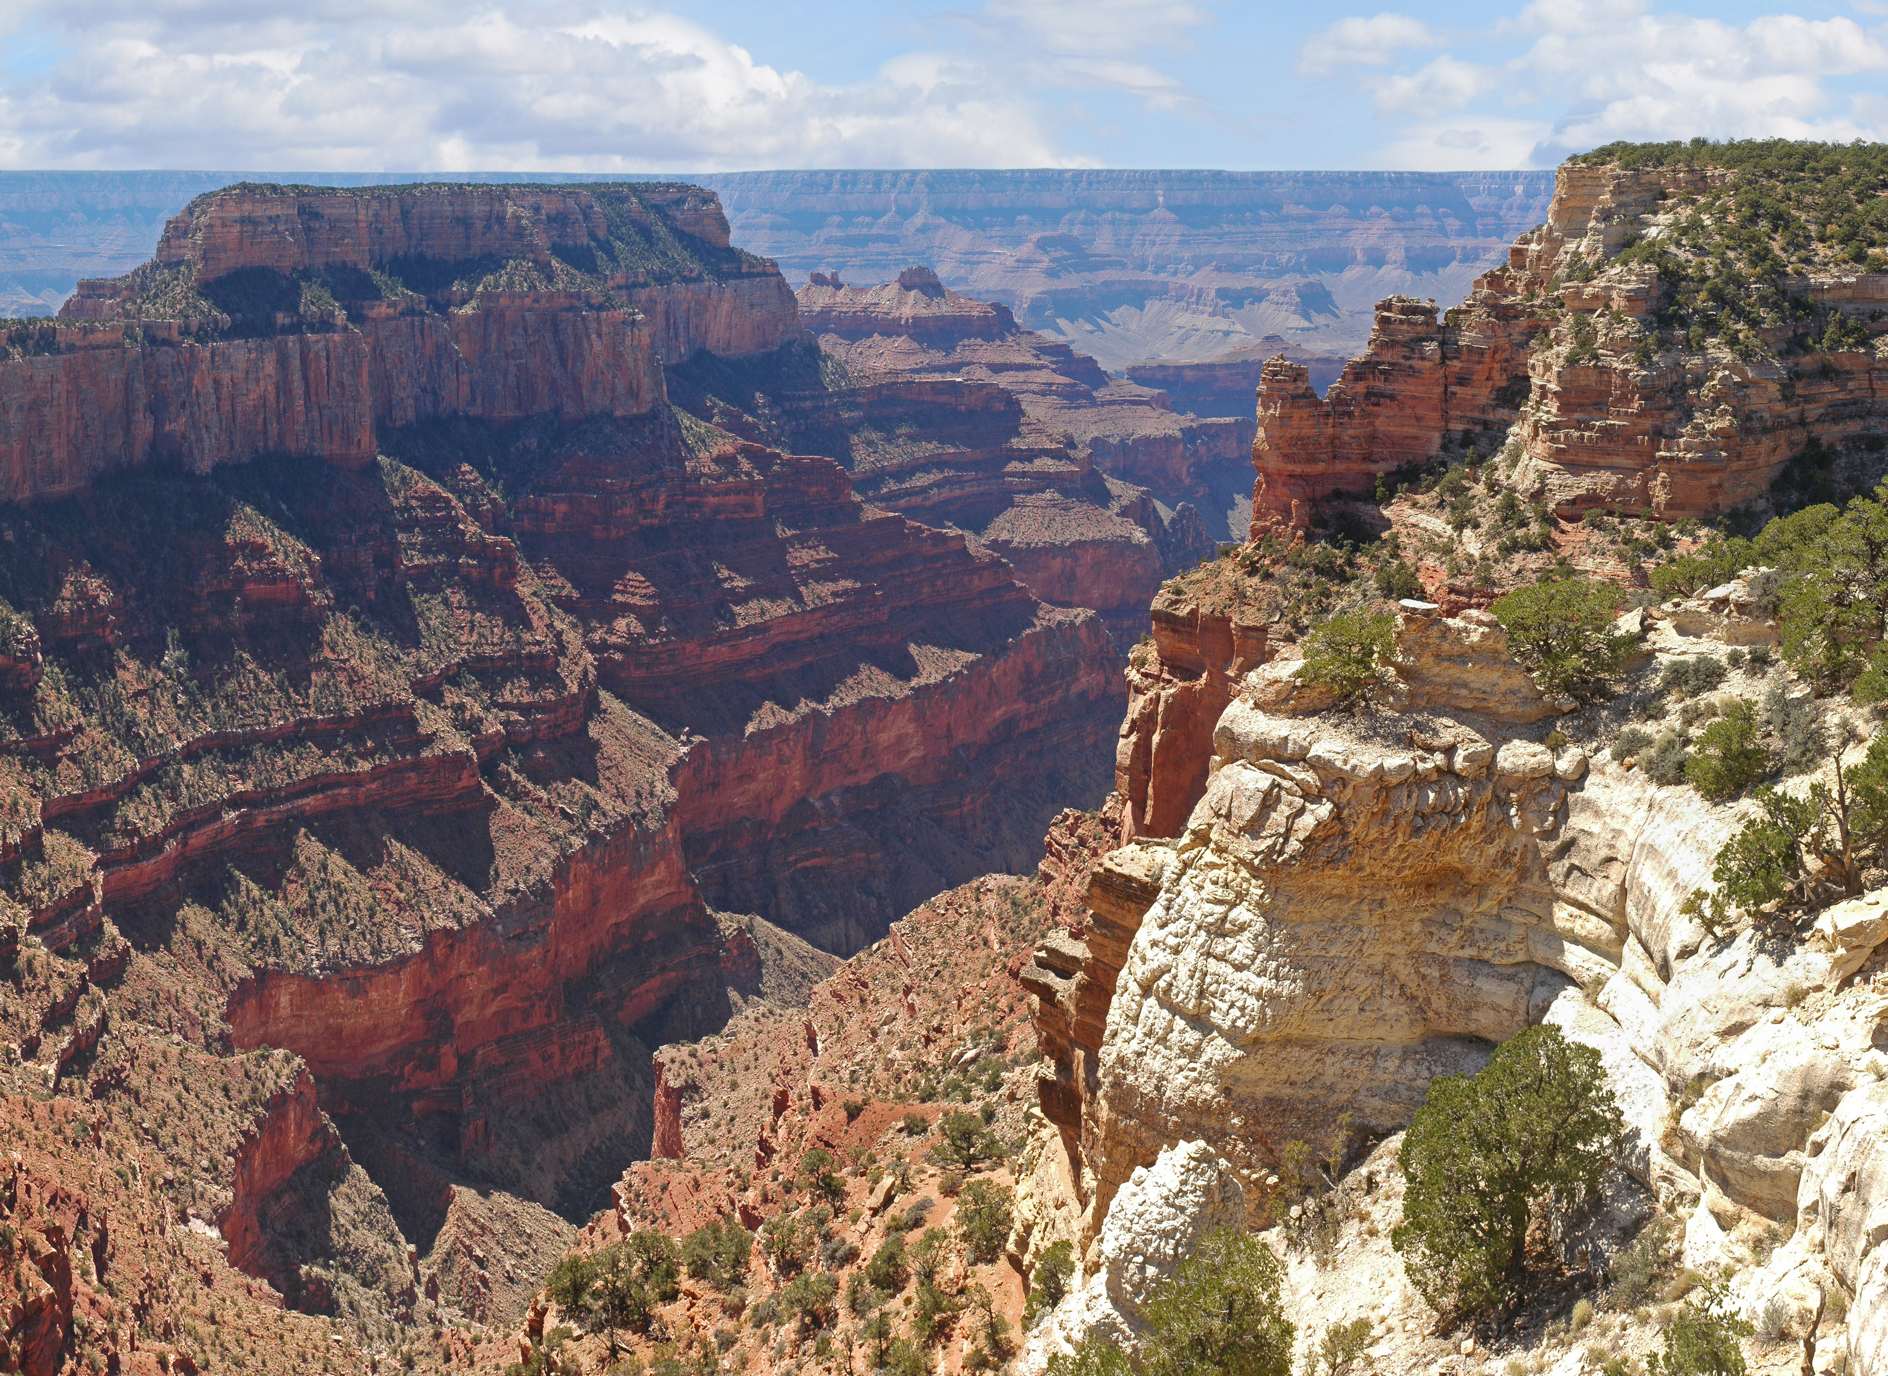

Grand Canyon National Park: View from Cape Royal on the North Rim. NPS/M.Quinn

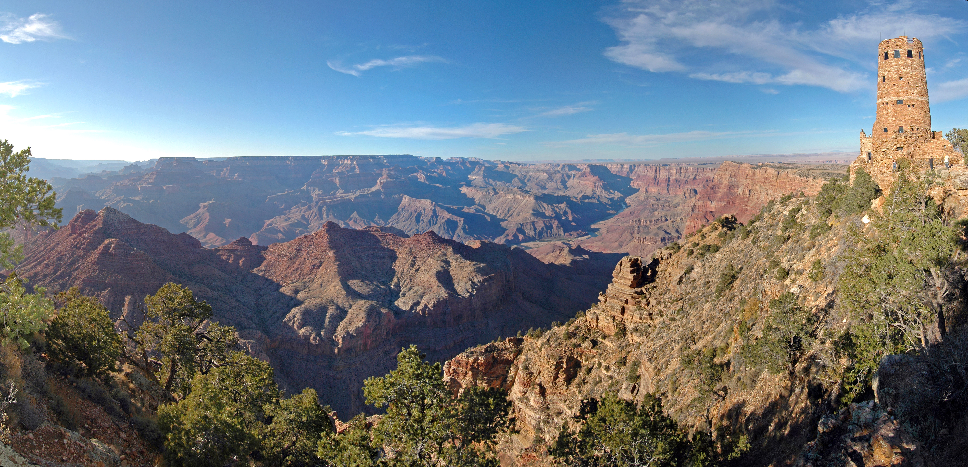

Grand Canyon National Park: Desert View Watchtower (South Rim). NPS/M.Quinn

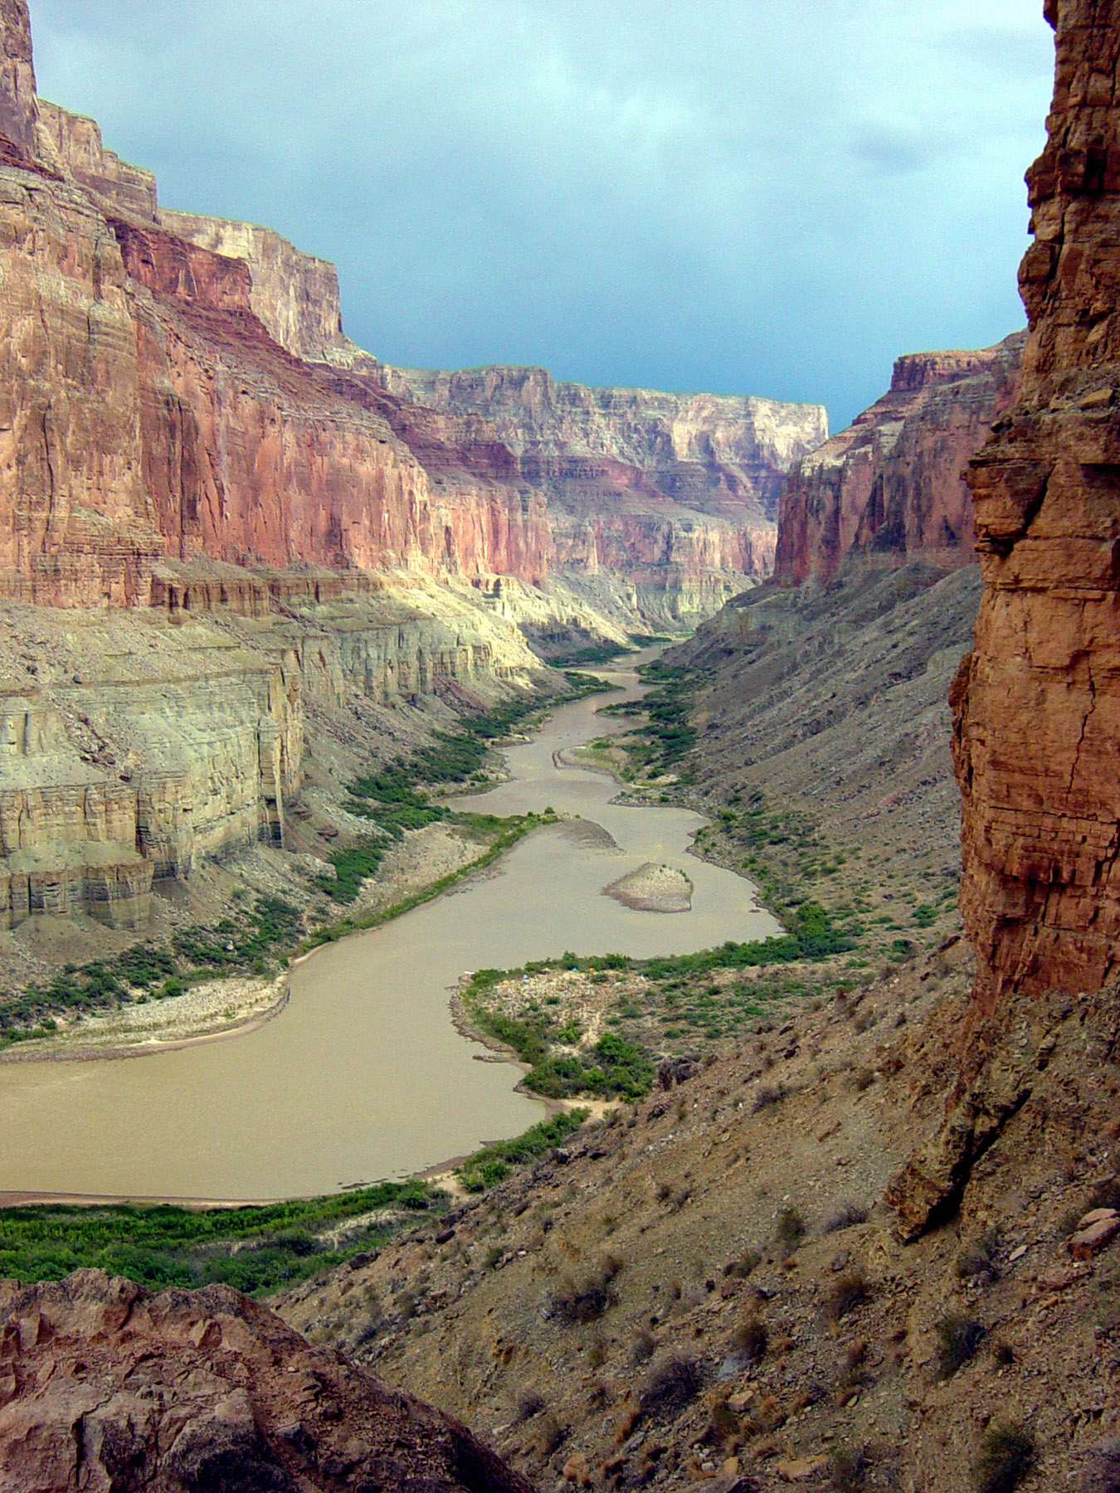

Looking down the Colorado River from Nankoweap at river mile 53. NPS/M.Quinn

## Operating Hours

Both Desert View (East Entrance) and South Entrance are Open 24 hours/day and 7 Days/week. Credit cards, Recreation.gov, Your Pass Now, and America the Beautiful passes are accepted for entry. Cash is not accepted at this time. The South Entrance Station, near Tusayan, Arizona, receives the most traffic, an experiences long lines and up to 2 hour wait times between 9:30 am and 4 pm. The East Entrance at Desert View (accessed via US 89 to Cameron, AZ, then west on SR 64, usually has shorter wait times.

## Contact Information

### Address

20 South Entrance Road  
AZ  
86023

### Website

https://www.nps.gov/grca/index.htm

# Kenai Fjords National Park

## Description

At the edge of the Kenai Peninsula lies a land where the ice age lingers. Nearly 40 glaciers flow from the Harding Icefield, Kenai Fjords' crowning feature. Wildlife thrives in icy waters and lush forests around this vast expanse of ice. Sugpiaq people relied on these resources to nurture a life entwined with the sea. Today, shrinking glaciers bear witness to the effects of our changing climate.

## Weather

The weather Kenai Fjords is difficult to predict and can change rapidly. The area generally enjoys a relatively temperate maritime climate, primarily due to the influence of the Japanese current that flows through the Gulf of Alaska. Summer daytime temperatures range from the mid 40s to the low 70s (Fahrenheit). Overcast and cool rainy days are frequent. Winter temperatures can range from the low 30s to -20.

## Activities

* Astronomy
* Boating
* Fixed Wing Flying
* Front-Country Hiking
* Junior Ranger Program
* Mountain Climbing

## Images

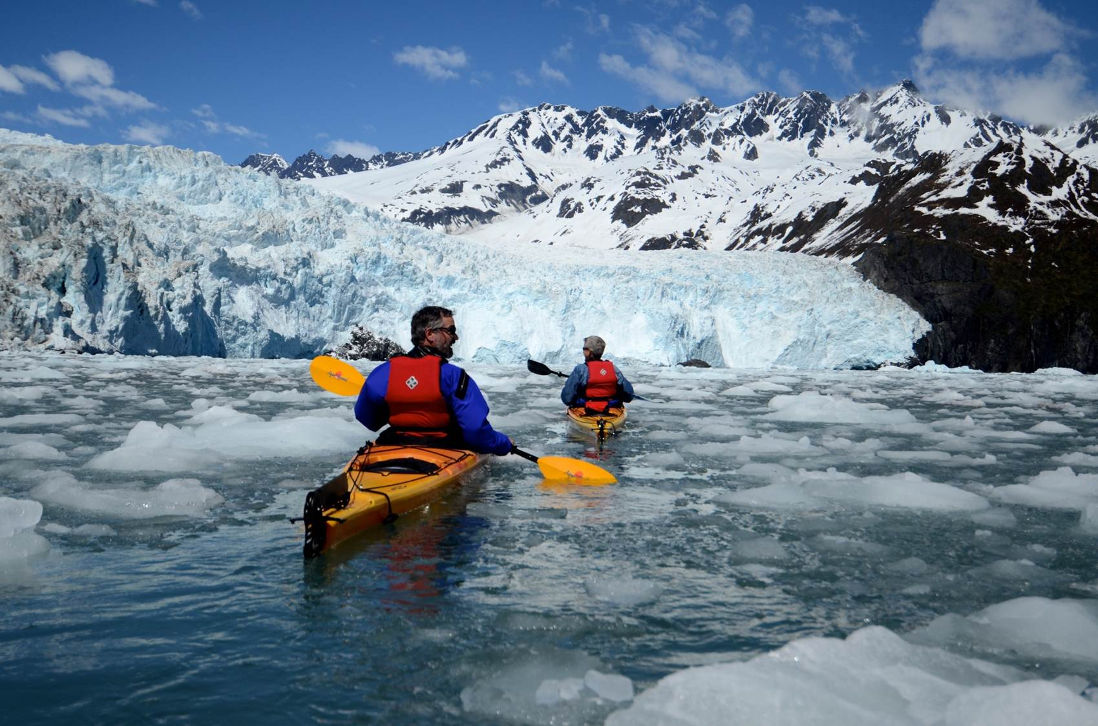

Aialik Bay Kayakers. NPS Photo

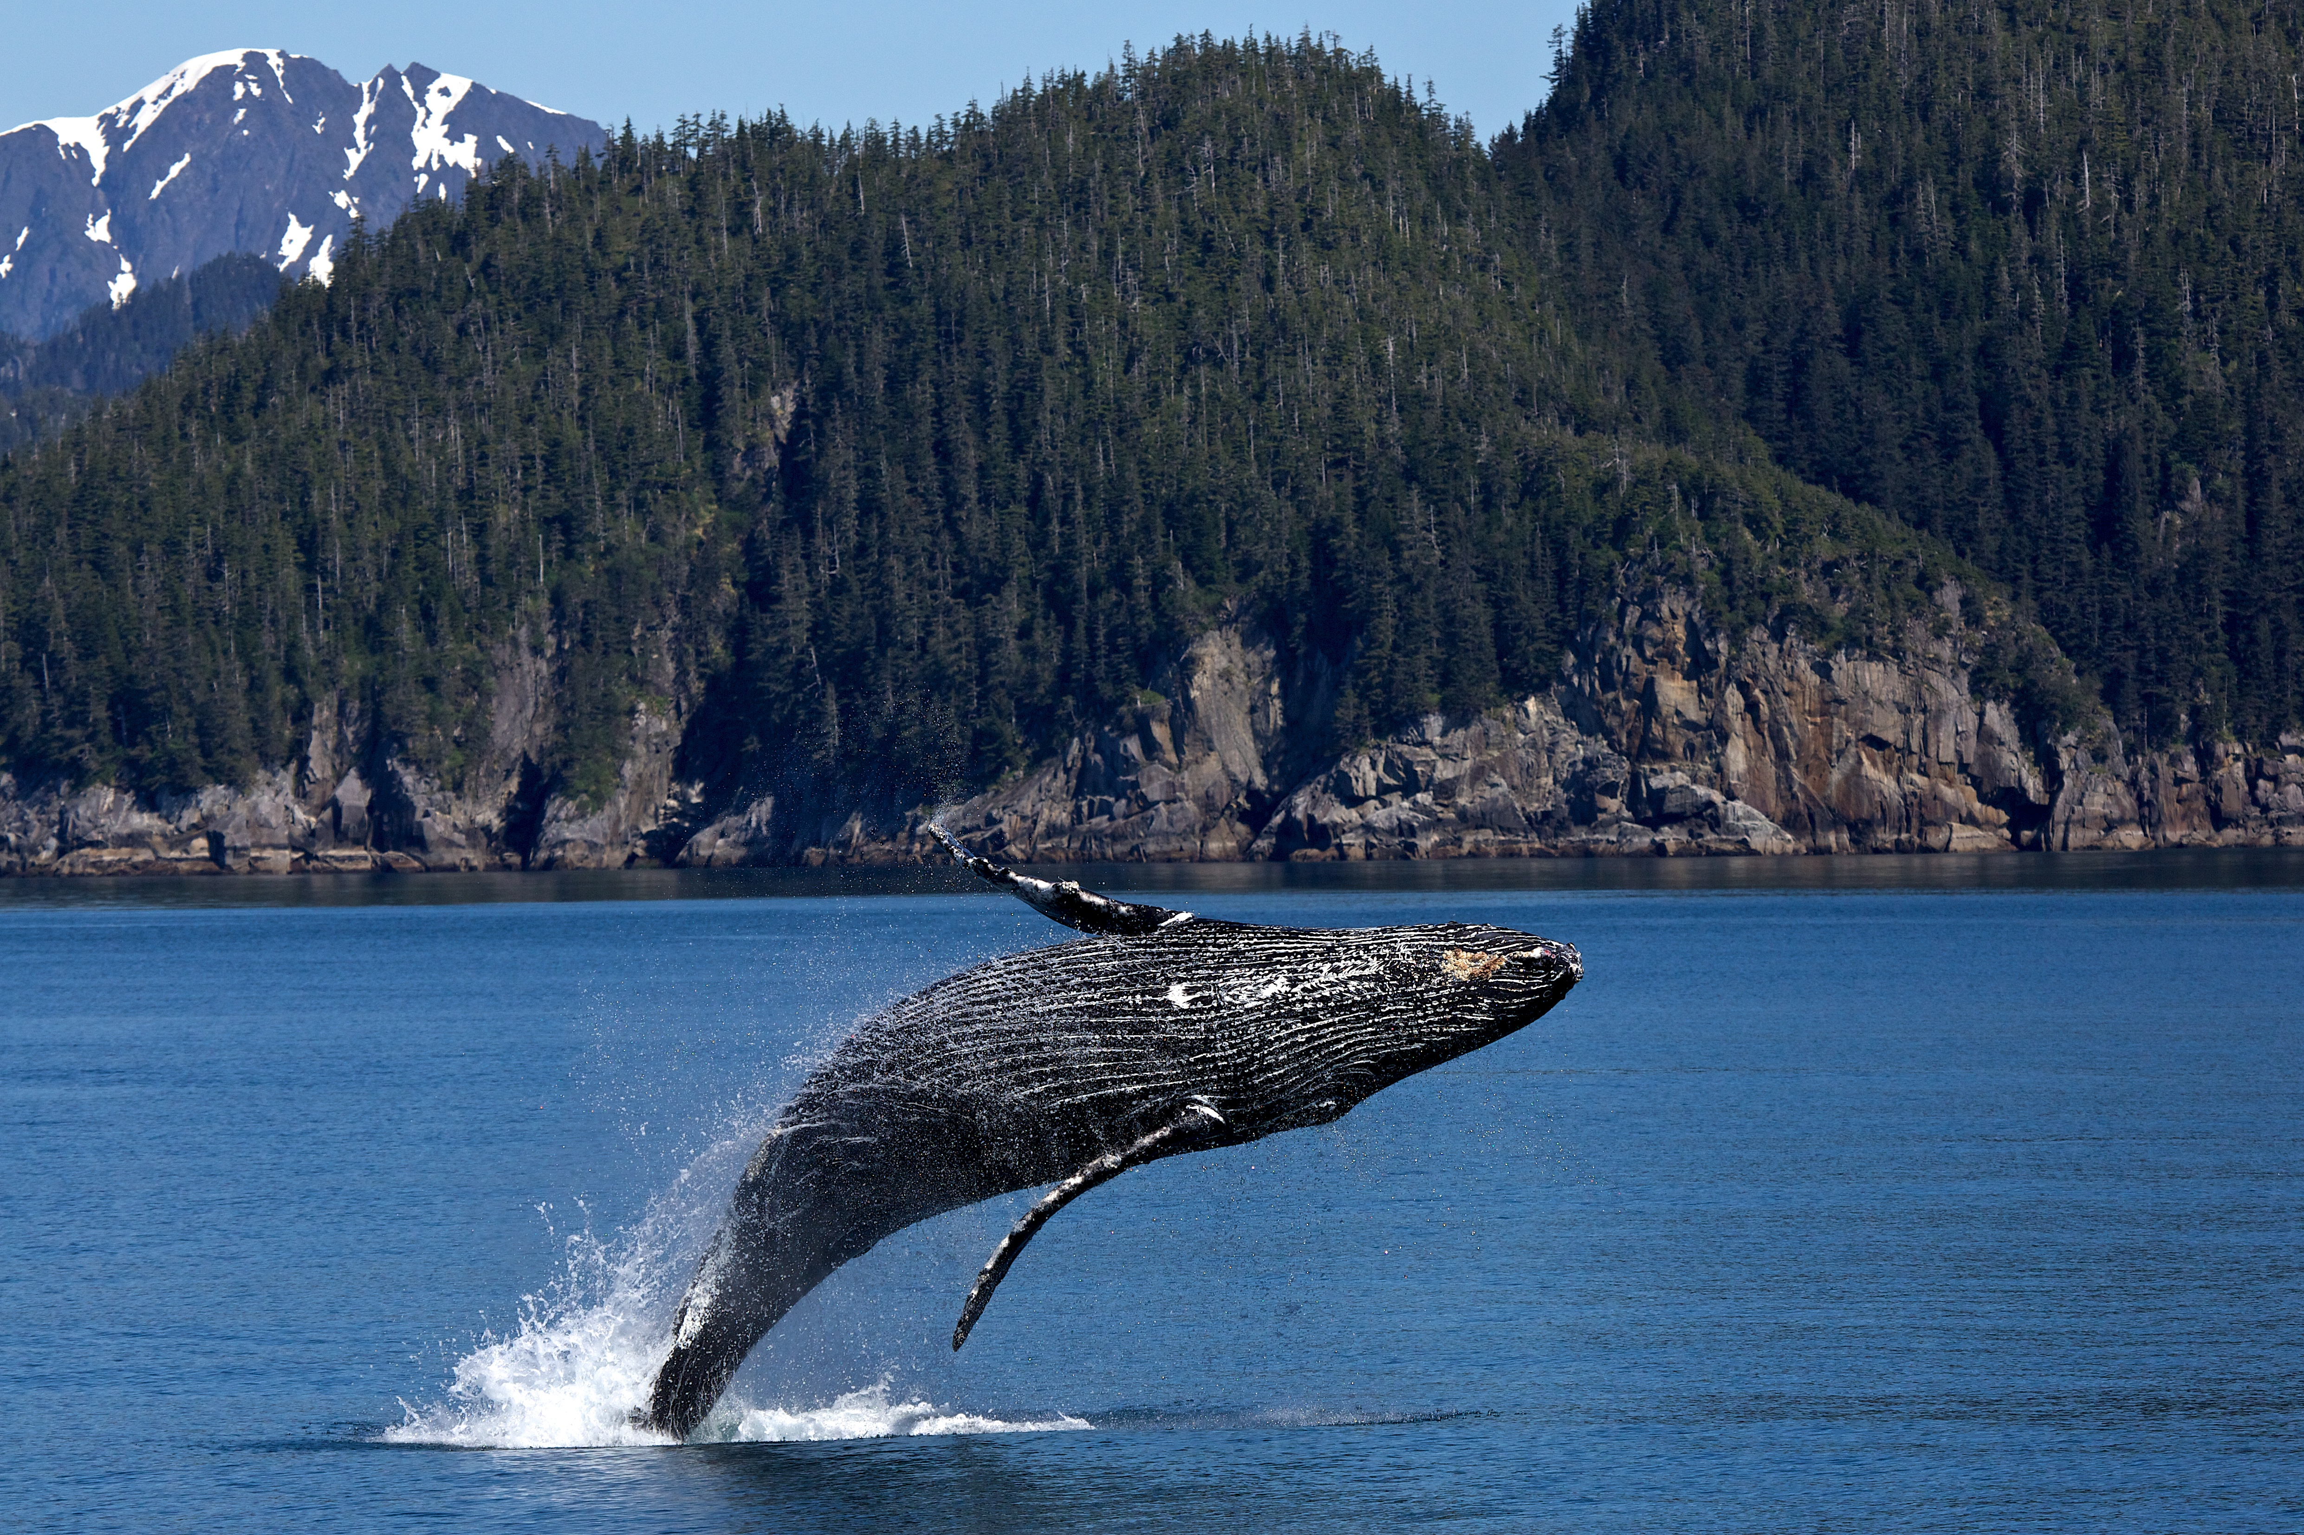

Humpback Whale Breach. NPS Photo/Thoresen

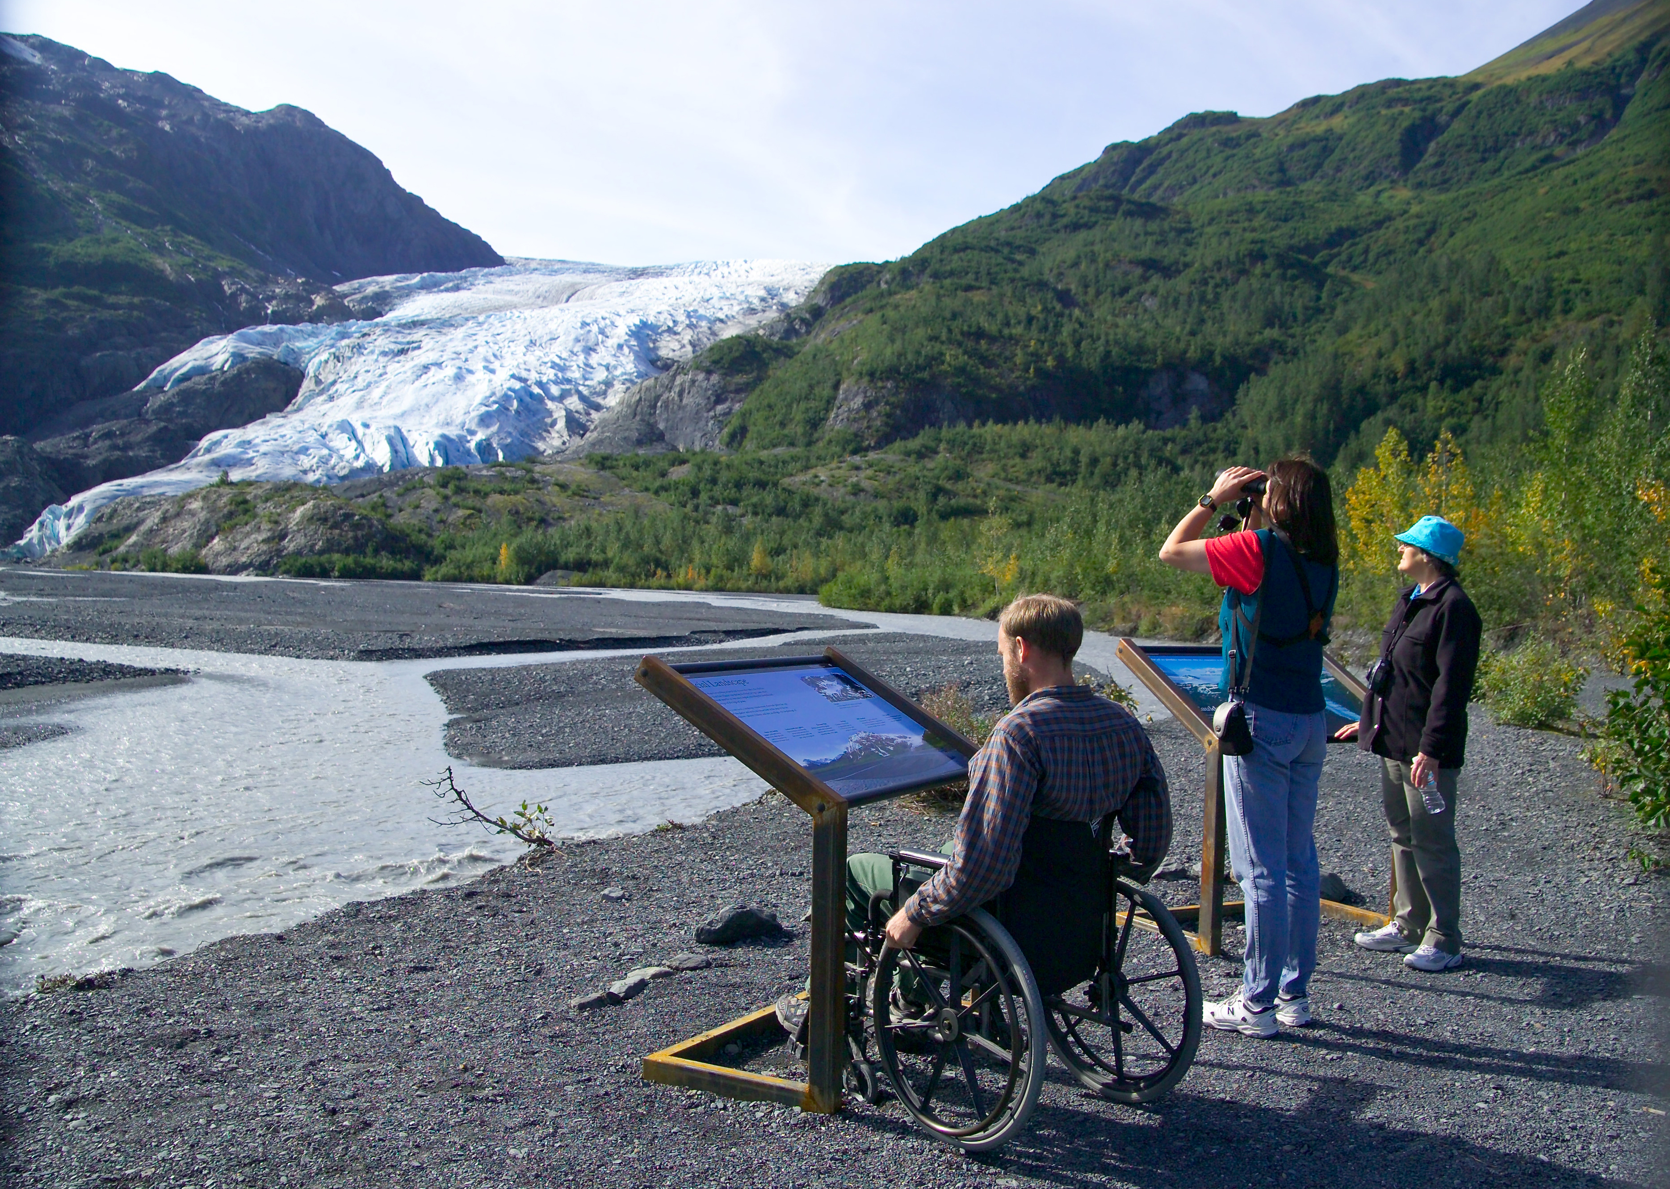

Exit Glacier View. NPS Photo/Jim Pfeiffenberger

## Operating Hours

The park is open year-round. The primary months to visit are June, July, and August. There are reduced services in the area during the months of May and September.  
  
The road to the Exit Glacier area is not plowed during the winter months, and is closed to vehicle traffic once it is covered in snow and ice.  
  
The park's coastal backcountry in also largely inaccessible late fall through the early spring due to rough seas.

## Contact Information

### Address

411 Washington Street  
AK  
99664

### Website

https://www.nps.gov/kefj/index.htm

# Yosemite National Park

## Description

Not just a great valley, but a shrine to human foresight, the strength of granite, the power of glaciers, the persistence of life, and the tranquility of the High Sierra. First protected in 1864, Yosemite National Park is best known for its waterfalls, but within its nearly 1,200 square miles, you can find deep valleys, grand meadows, ancient giant sequoias, a vast wilderness area, and much more.

## Weather

Yosemite National Park covers nearly 1,200 square miles (3,100 square km) in the Sierra Nevada, with elevations ranging from about 2,000 feet (600 m) to 13,000 ft (4,000 m). Yosemite receives 95% of its precipitation between October and May (and over 75% between November and March). Most of Yosemite is blanketed in snow from about November through May. (Yosemite Valley can be rainy or snowy in any given winter storm.)

## Activities

* Biking
* Bookstore and Park Store
* Climbing
* Food
* Hands-On
* Snow Play

## Images

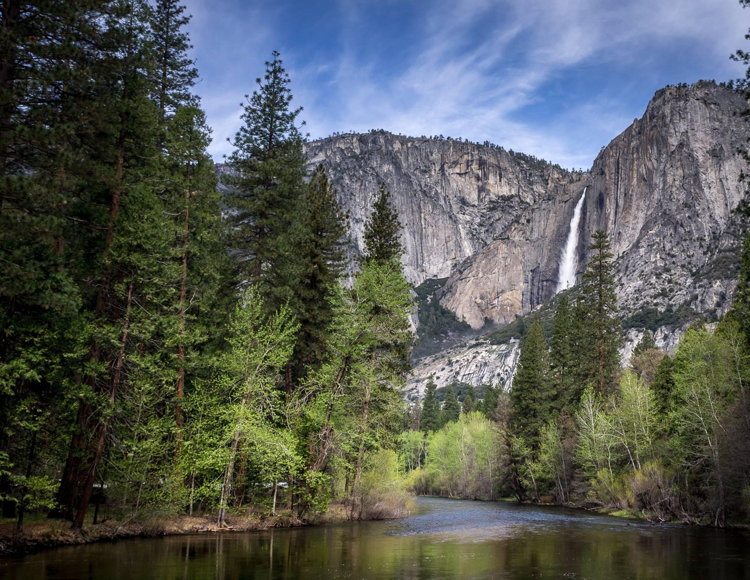

Upper Yosemite Fall and Merced River in spring. NPS Photo

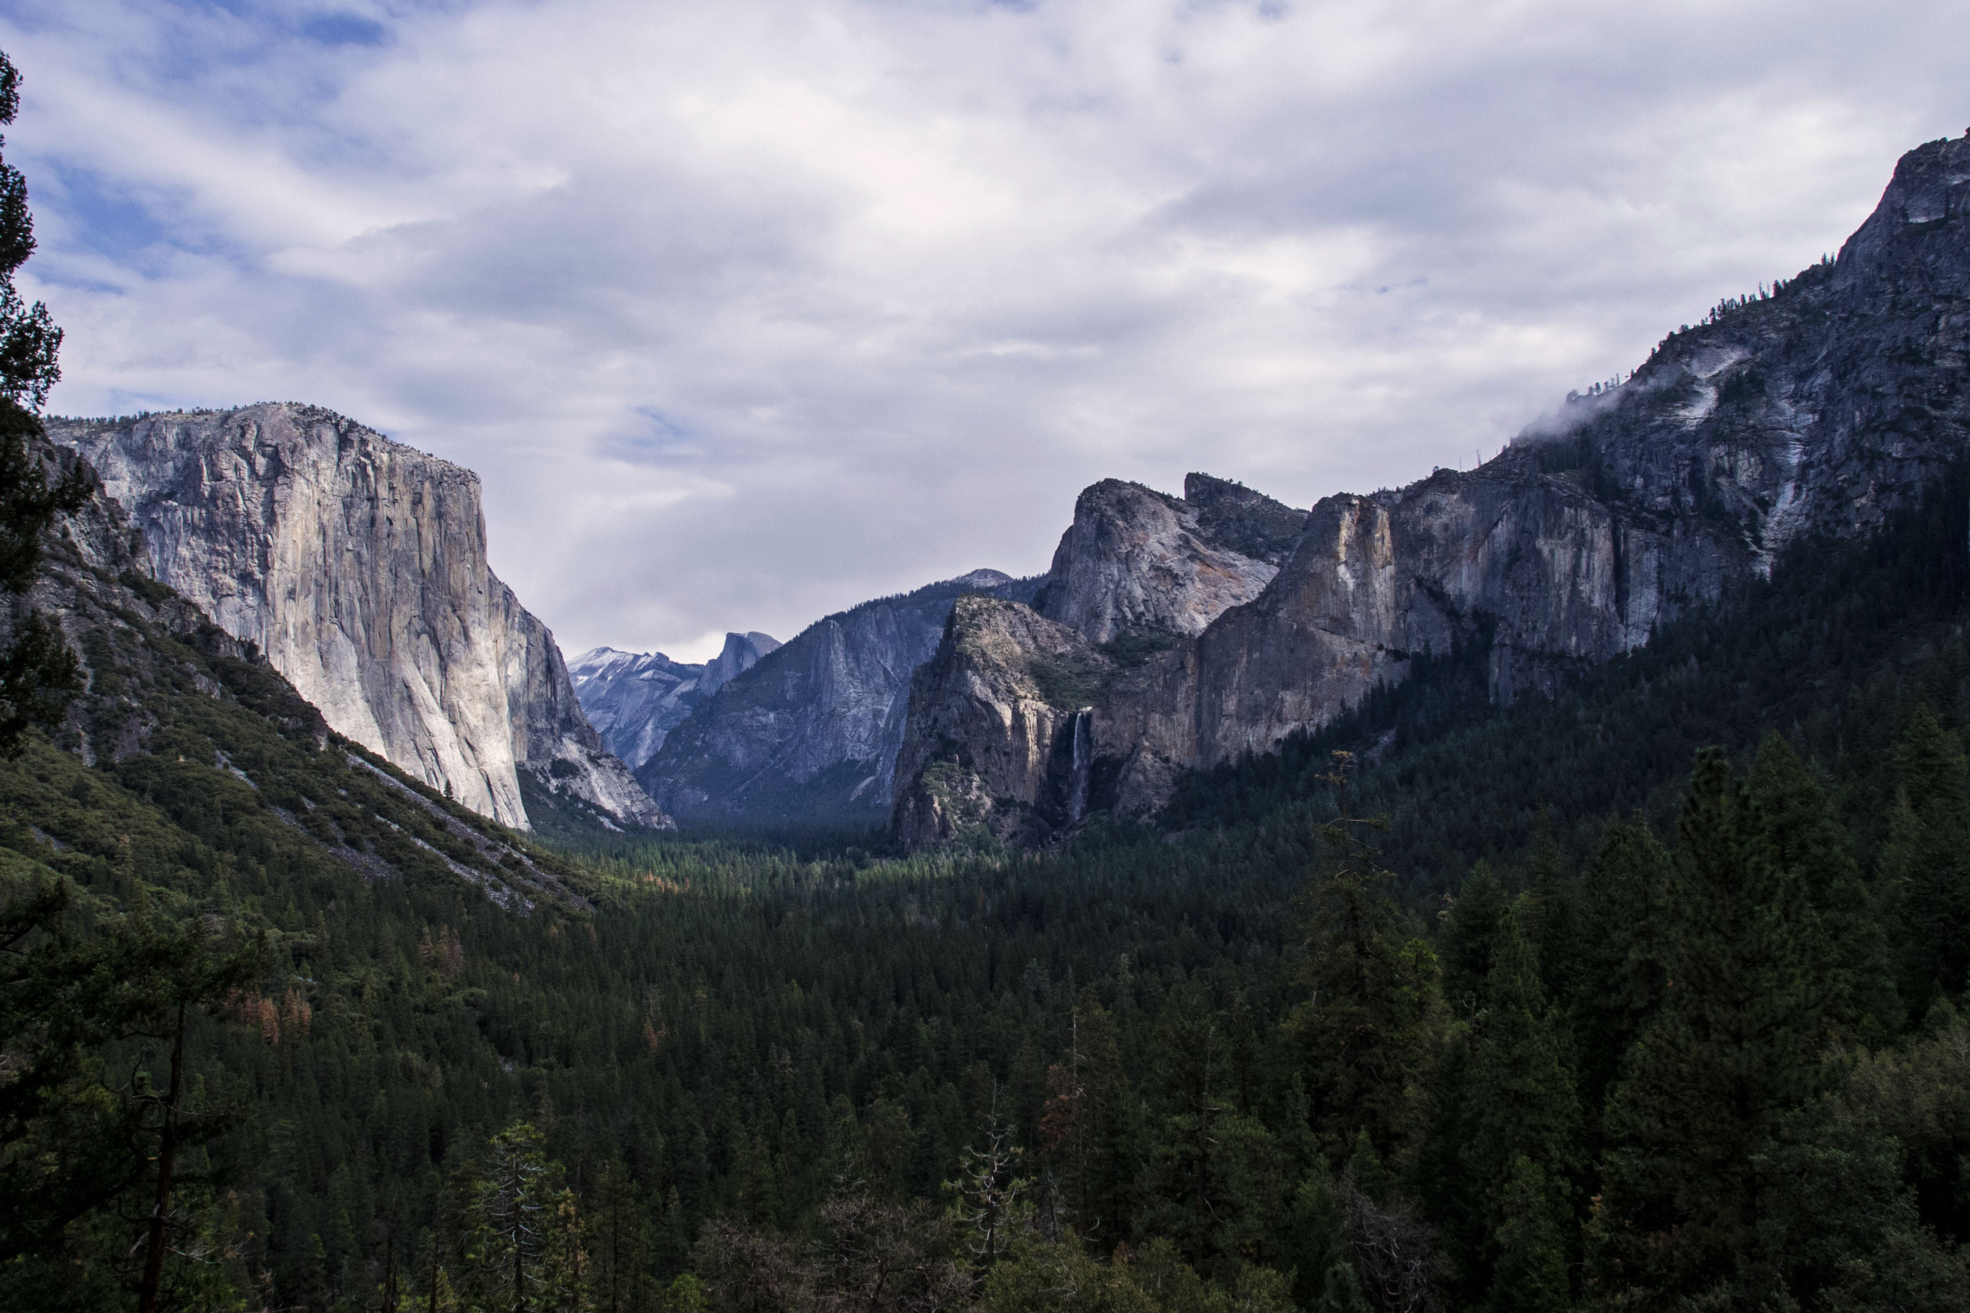

Yosemite Valley from Tunnel View. NPS / Cindy Jacoby

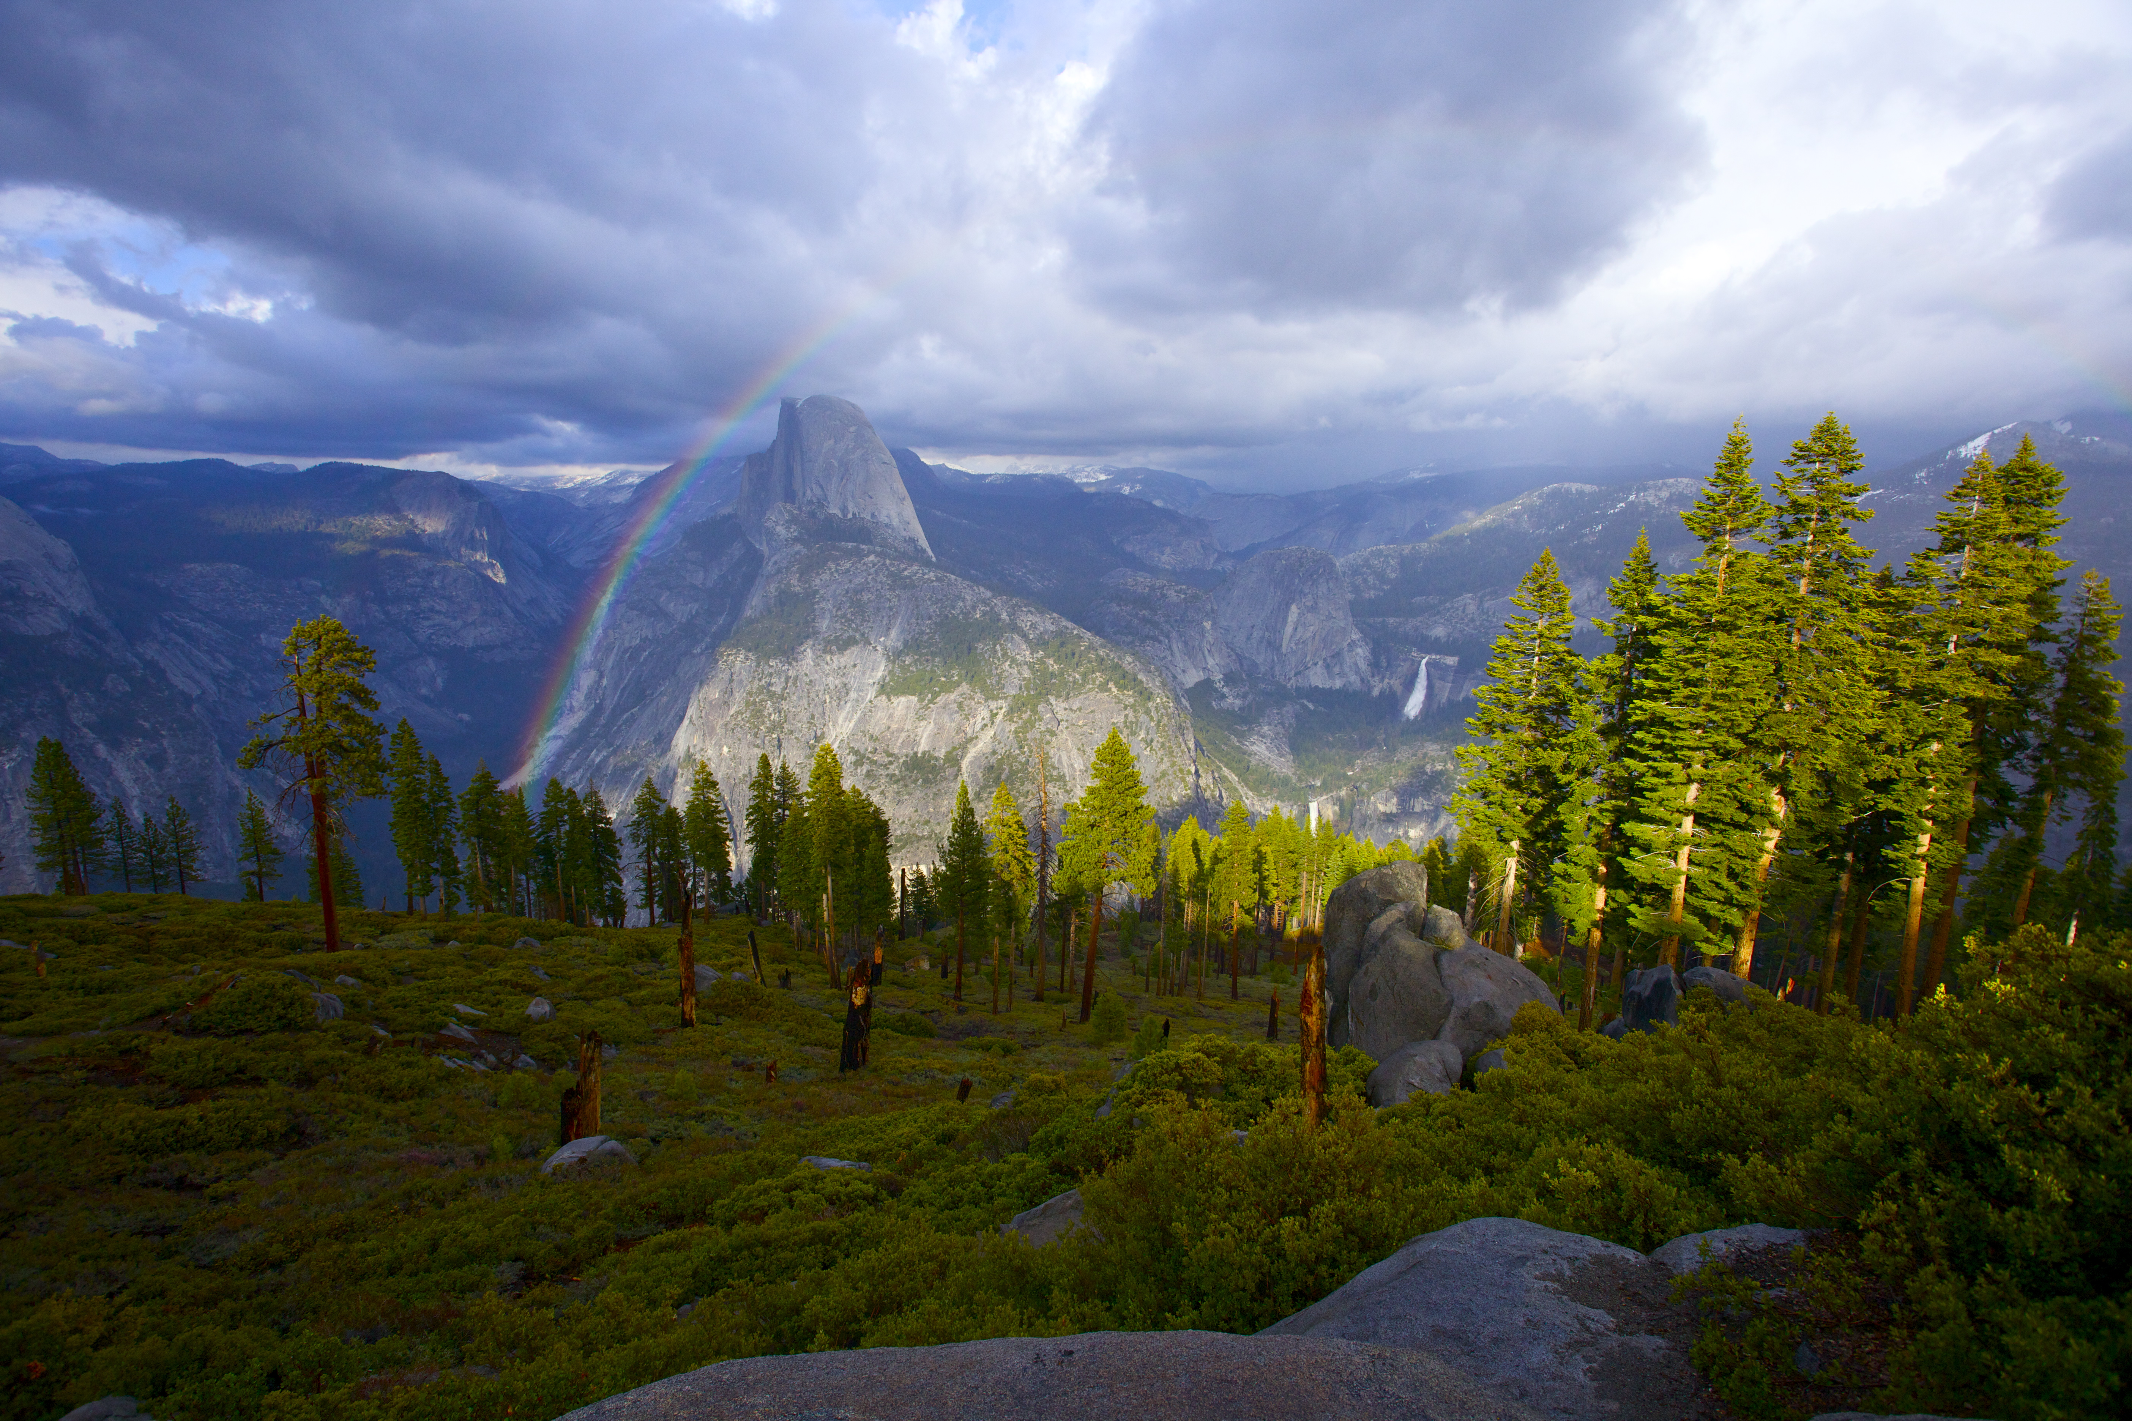

Rainbow over Half Dome. NPS / Bob Roney

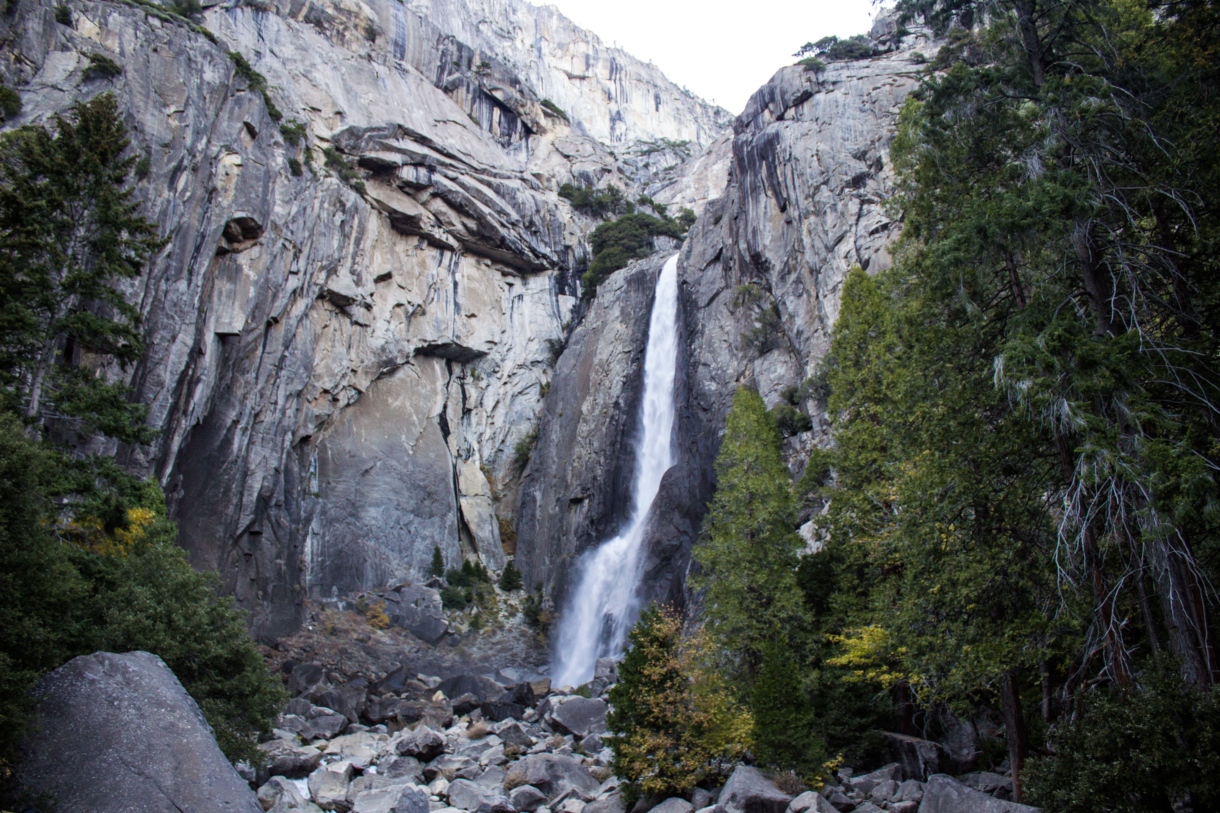

Lower Yosemite Fall. NPS Photo / Cindy Jacoby

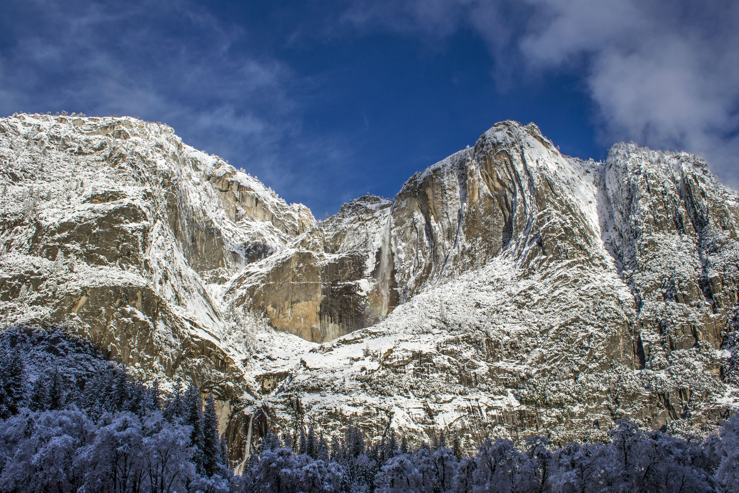

Yosemite Falls on a Winter Morning. NPS / Cindy Jacoby

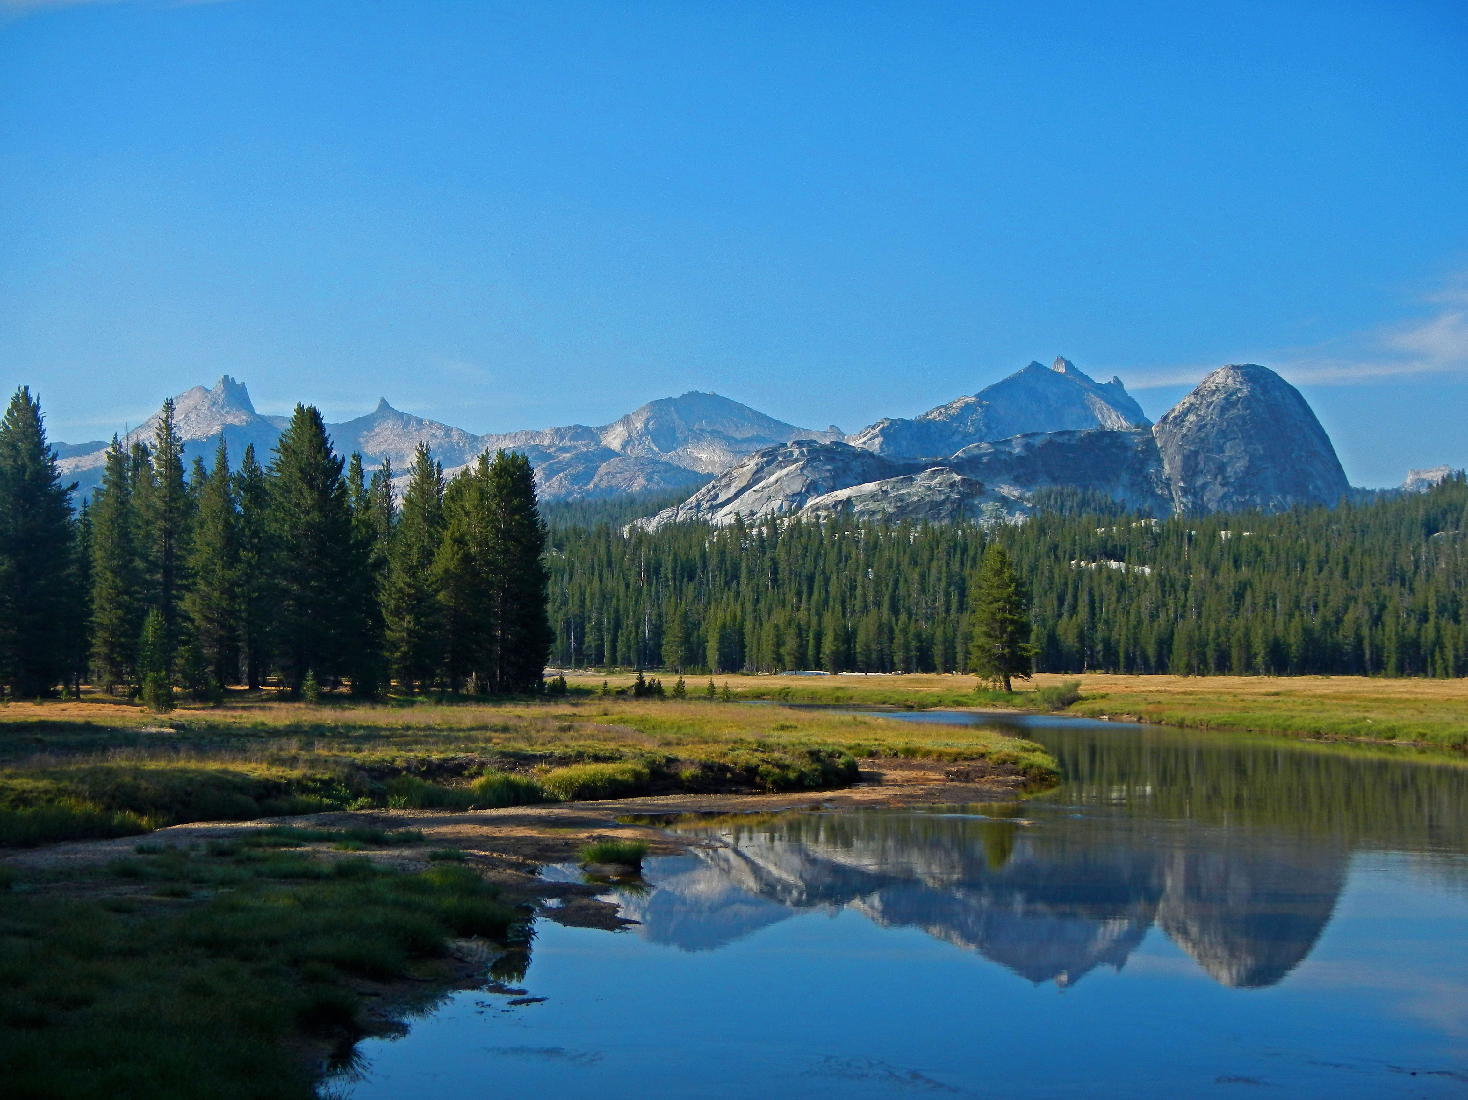

Glen Aulin. NPS

## Operating Hours

Yosemite National Park is open 24 hours per day, 365 days per year.

## Contact Information

### Address

9039 Village Drive  
CA  
95389

### Website

https://www.nps.gov/yose/index.htm

# Arches National Park

## Description

Visit Arches to discover a landscape of contrasting colors, land forms, and textures unlike any other in the world. The park has over 2,000 natural stone arches and hundreds of soaring pinnacles, massive rock fins, and giant balanced rocks. This red-rock wonderland will amaze you with its formations, refresh you with its trails, and inspire you with its sunsets.

## Weather

Arches is part of the Colorado Plateau, a "high desert" region that experiences wide temperature fluctuations, sometimes over 40 degrees in a single day. The temperate (and most popular) seasons are spring (April-May) and fall (mid-September-October), when daytime highs average 60 to 80 F and lows average 30 to 50 F. Summer temperatures often exceed 100 F, making strenuous exercise difficult. Winters are cold, with highs averaging 30 to 50 F, and lows averaging 0 to 20 F.

## Activities

* Backcountry Camping
* Bookstore and Park Store
* Camping
* Climbing
* Hiking
* Horse Trekking
* Horseback Riding
* Junior Ranger Program
* Stargazing

## Images

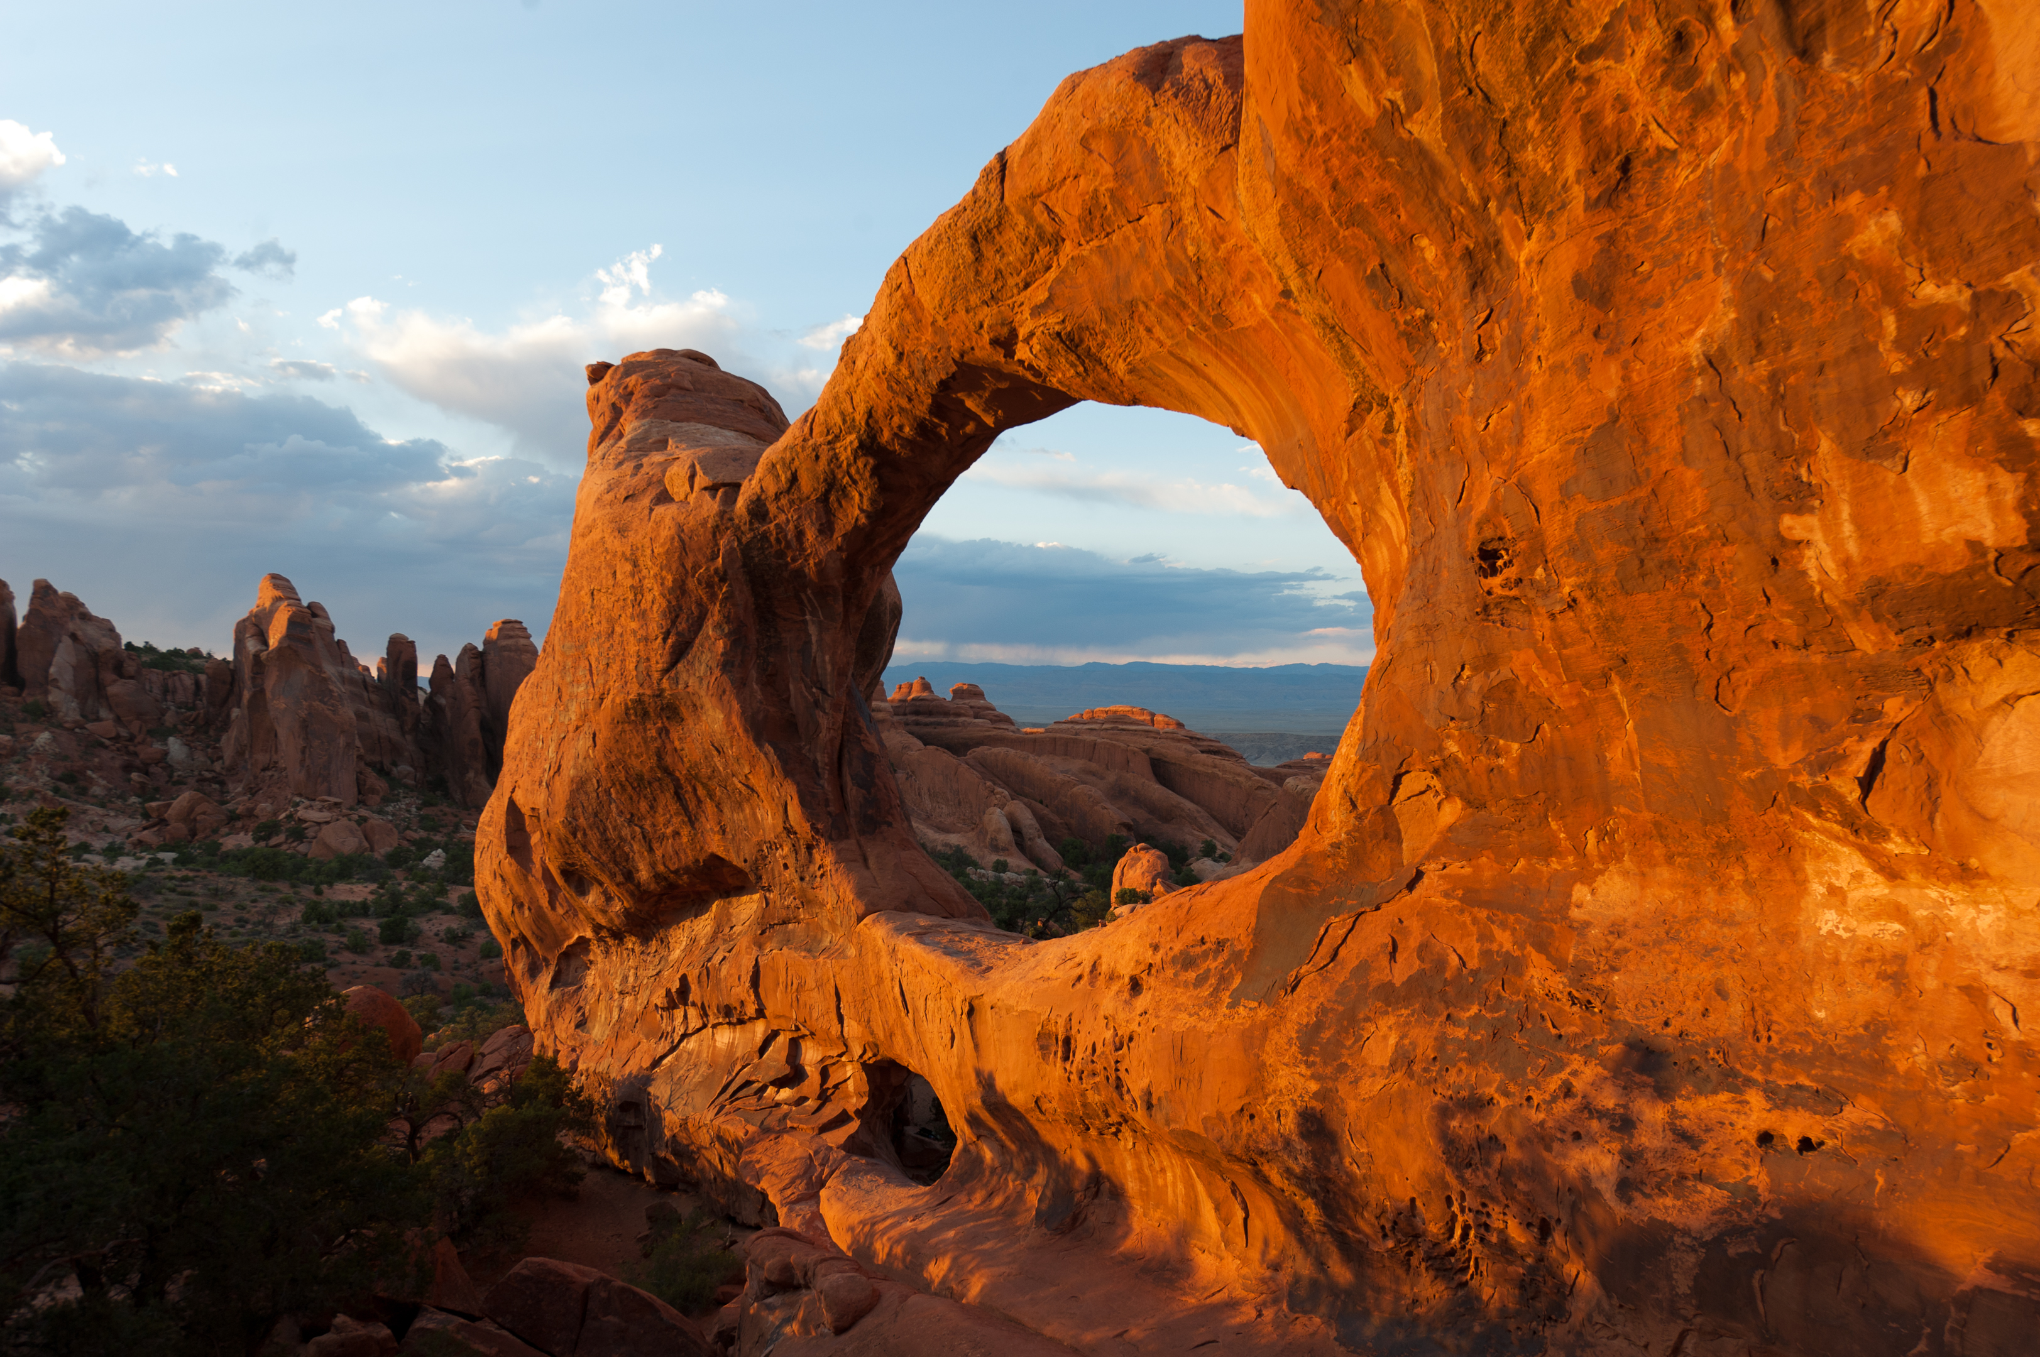

Double O Arch. NPS Photo

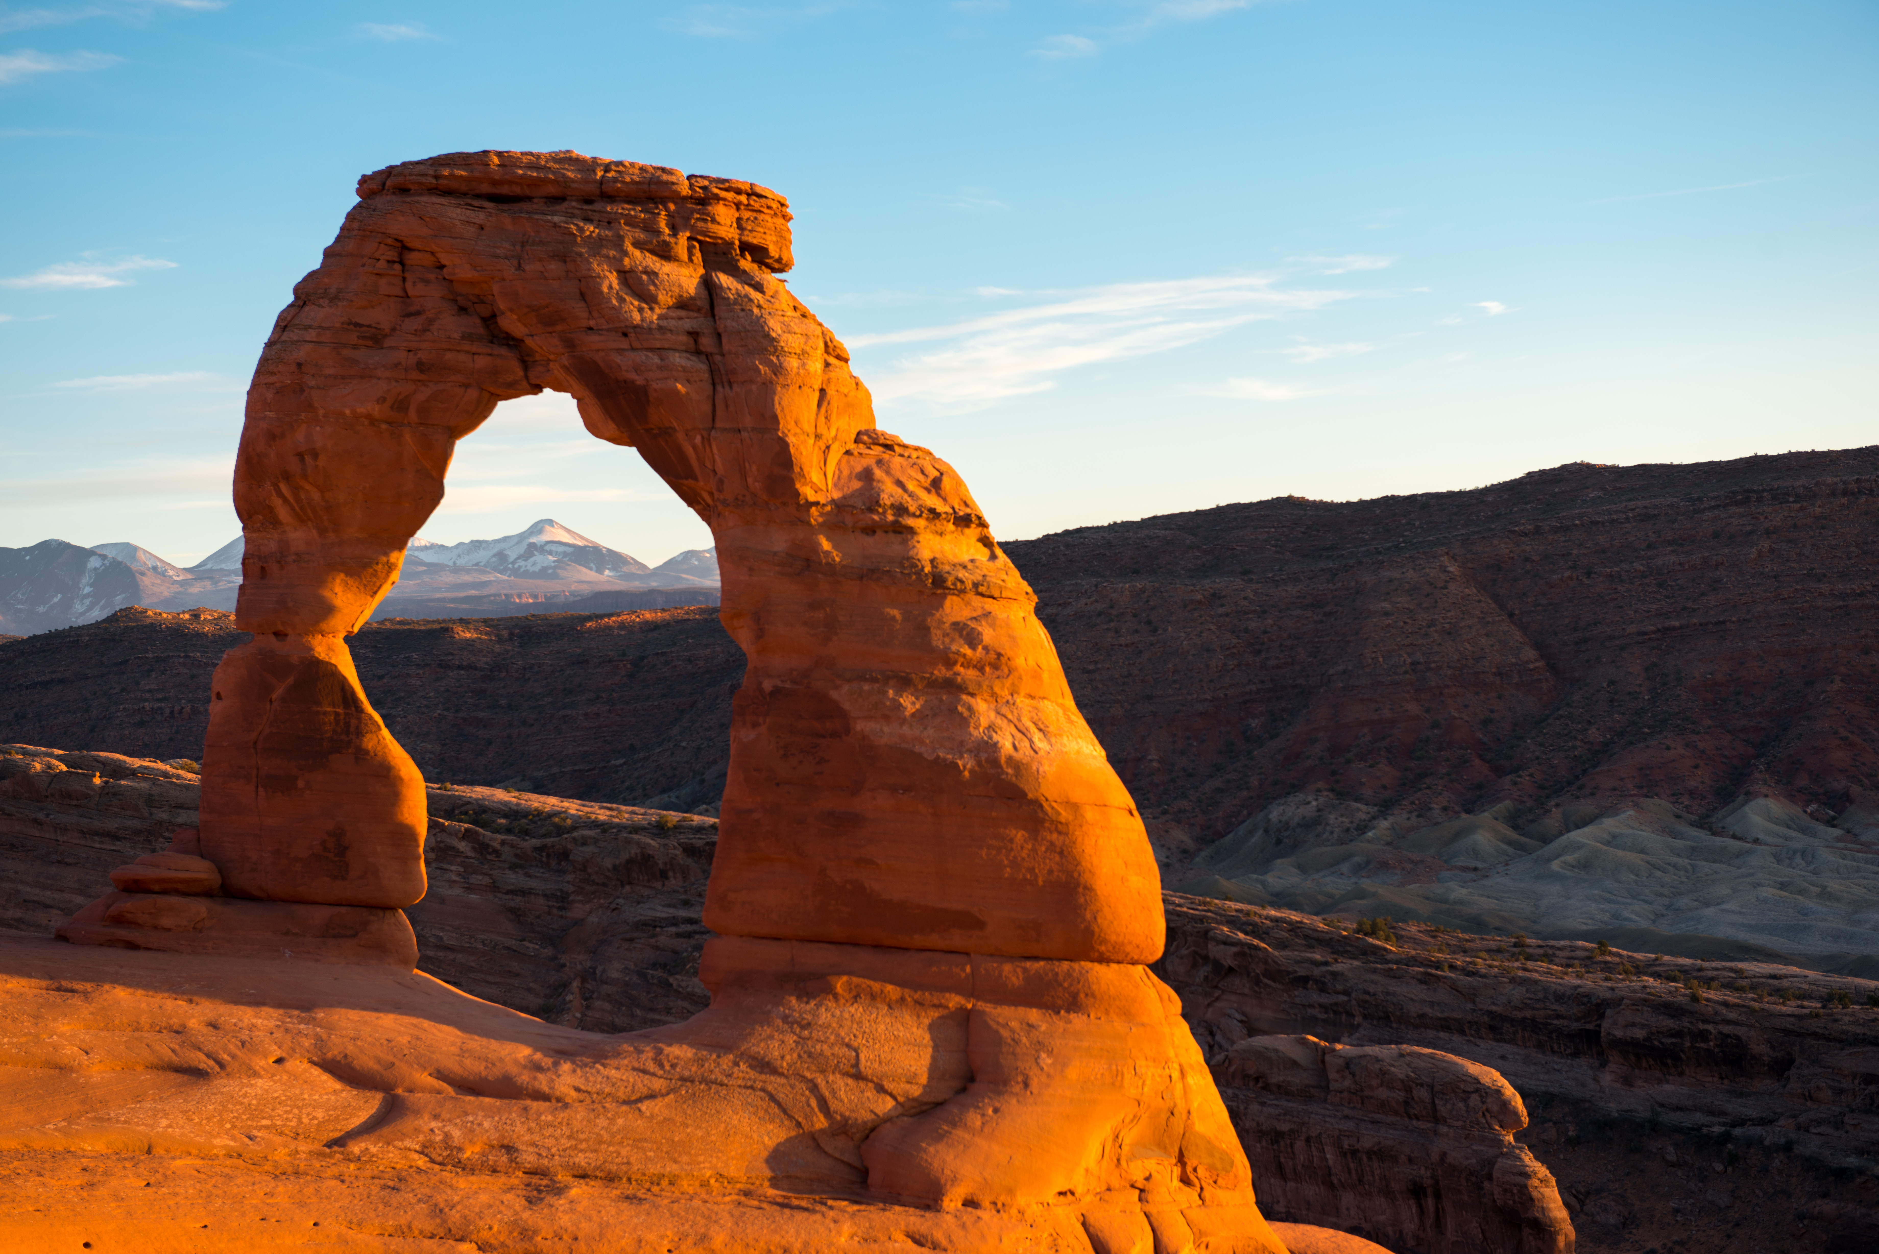

Delicate Arch. NPS Photo

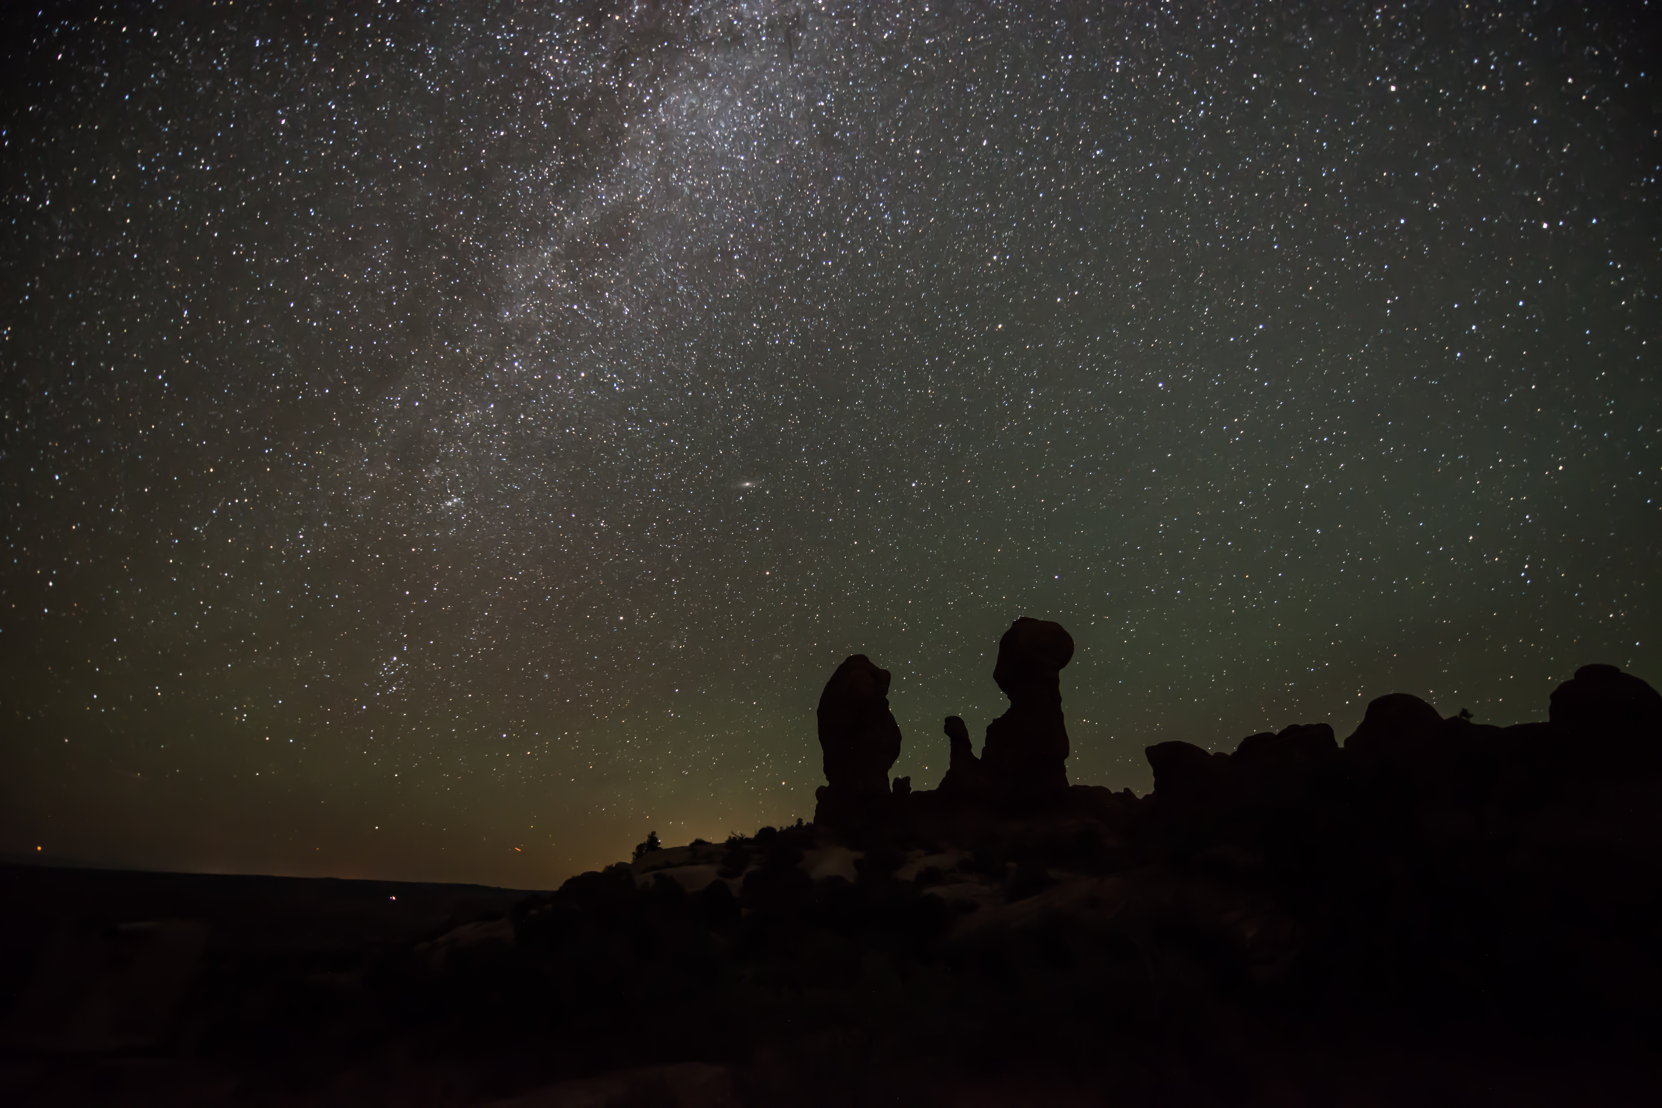

Milky Way over the Garden of Eden. NPS/Wonderly

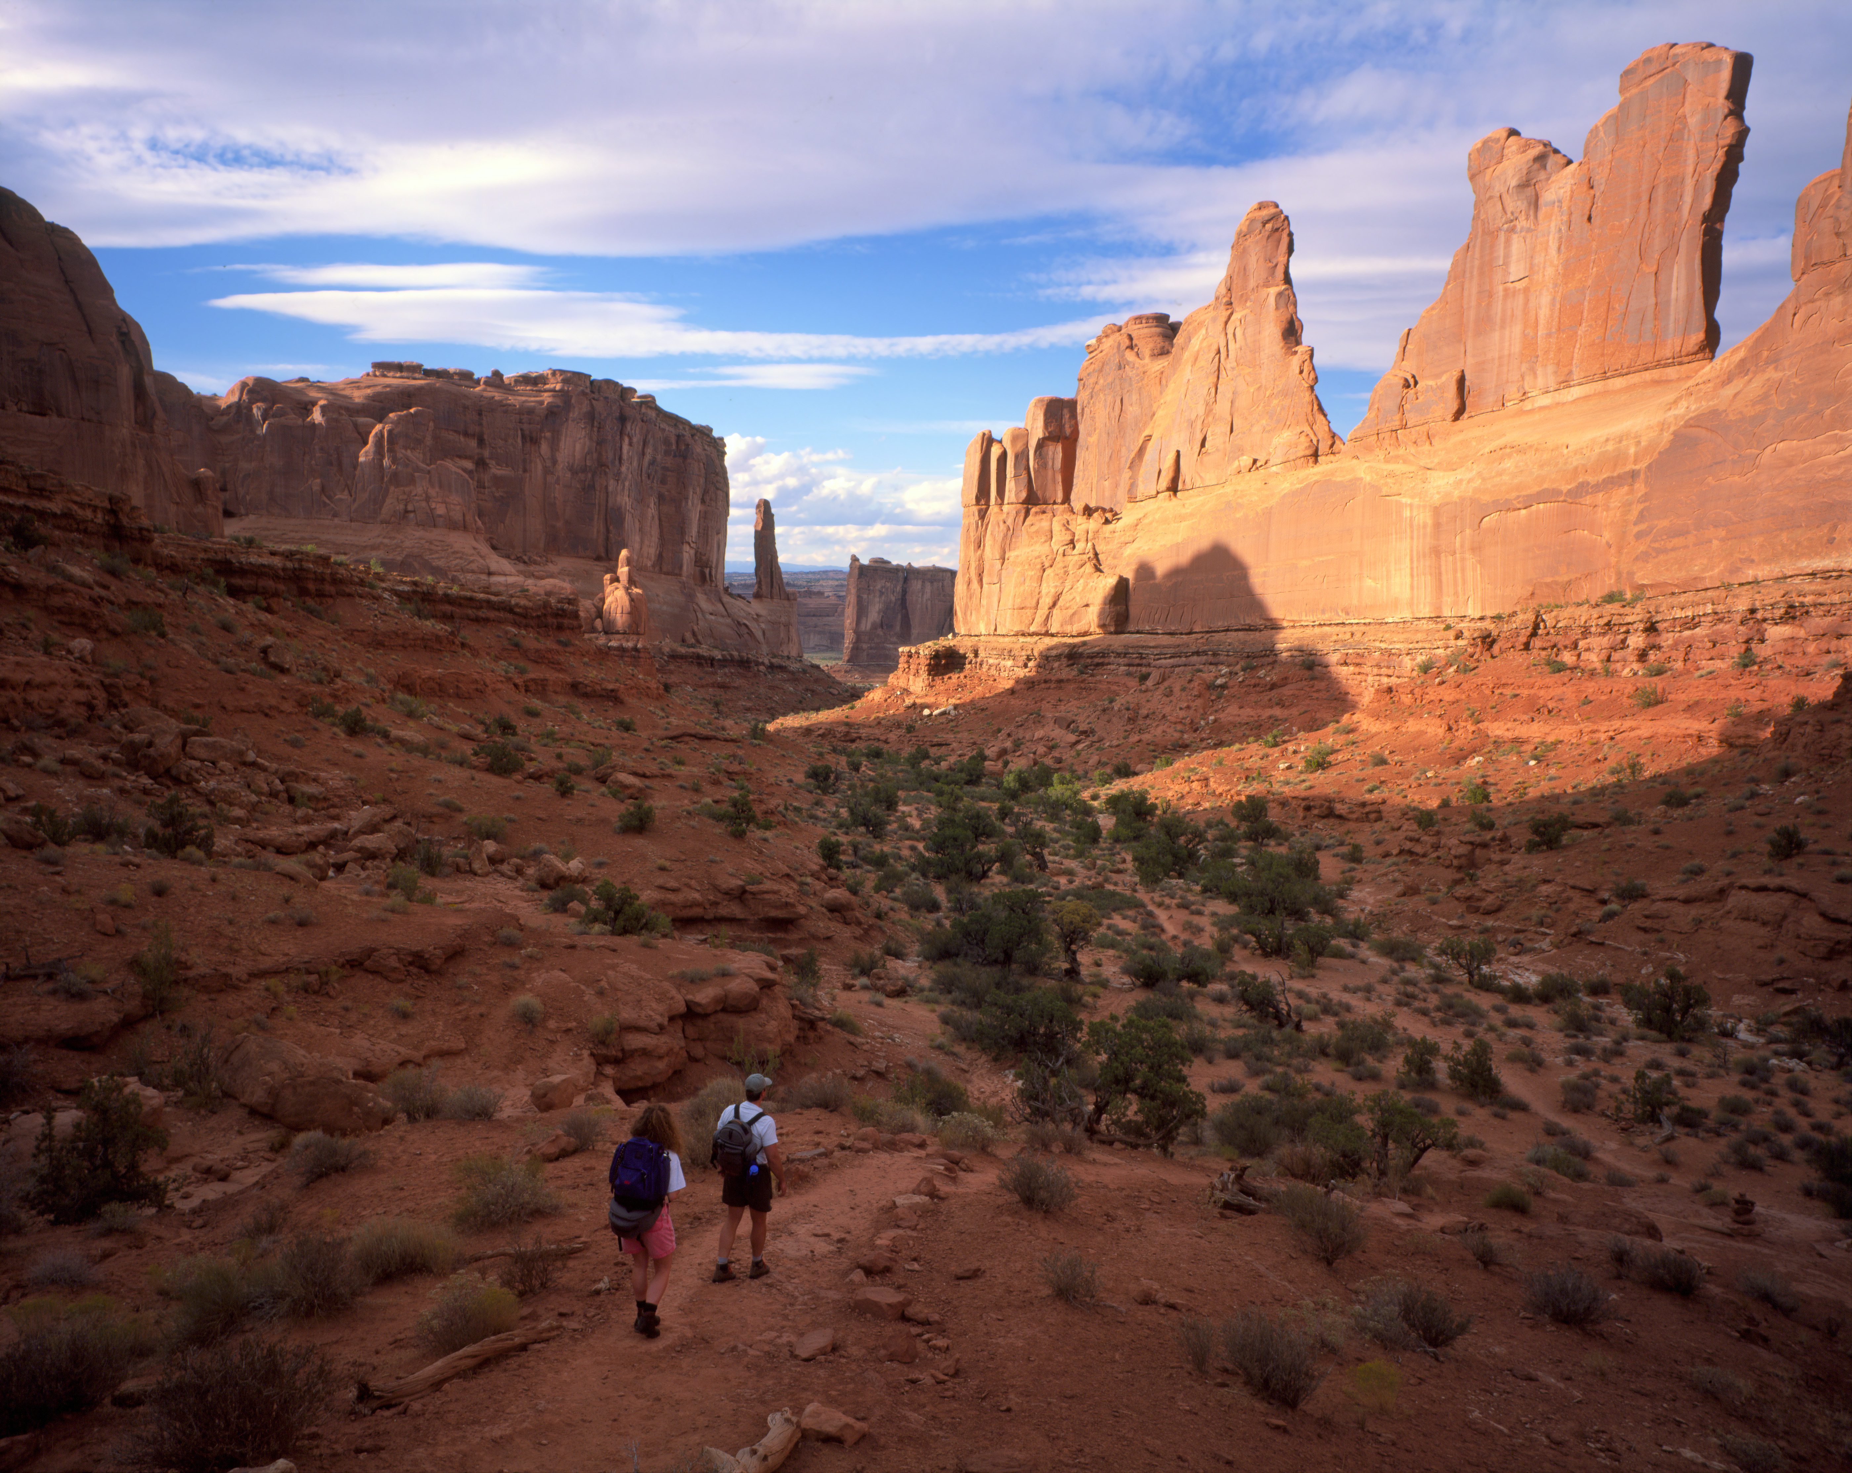

Park Avenue Trail. NPS/Herbert

## Operating Hours

Arches National Park is generally open 24 hours a day, year-round. Fees apply. The park is very busy between March and October. To avoid traffic, we recommend entering the park before 8 am or after 3 pm.

## Contact Information

### Address

5 miles north of Moab, Utah, on US 191  
UT  
84532

### Website

https://www.nps.gov/arch/index.htm

# Petrified Forest National Park

## Description

Park Hours: 8am to 5pm, MST. Don't forget that Arizona does not observe Daylight Savings. We are an hour earlier than New Mexico, Utah, and the Navajo Nation. Would you like to see the park film? It is located at the park's YouTube Channel.

## Weather

Petrified Forest National Park is a semi-arid grassland. Temperatures range from above 100° F (38° C) to well below freezing. About 10 inches (25.4 cm) of moisture comes during infrequent snow in the winter and often dramatic summer thunder-storms. Animals and plants are adapted to extremes in temperature and moisture. You should be ready too. Check out the forecast before you arrive and plan accordingly.

## Activities

* Backcountry Camping
* Dining
* Geocaching
* Gift Shop and Souvenirs
* Horse Camping (see also camping)
* Horseback Riding
* Self-Guided Tours - Walking

## Images

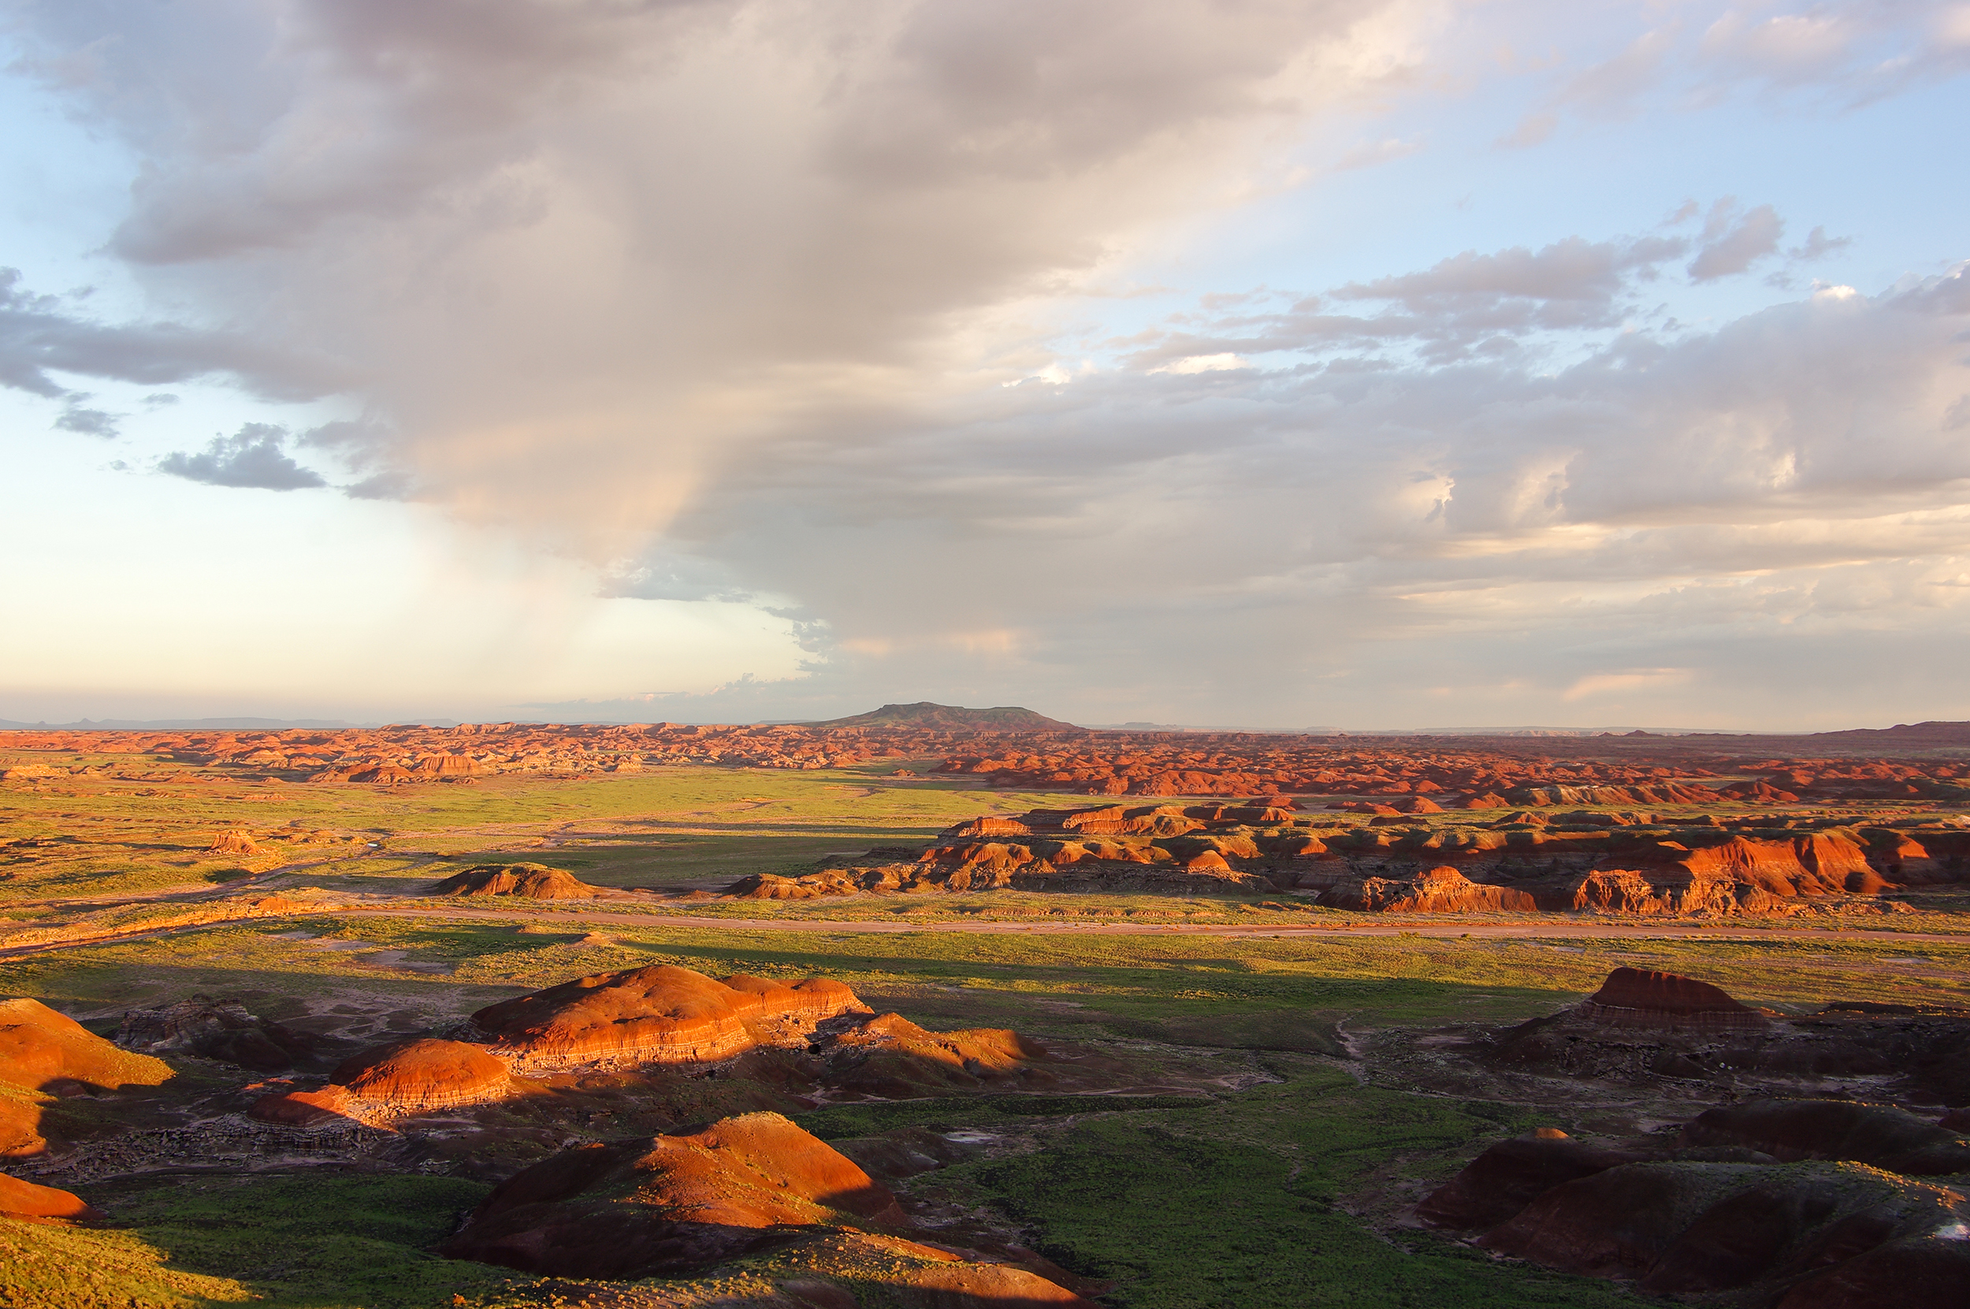

Petrified Forest National Wilderness Area. NPS Photo

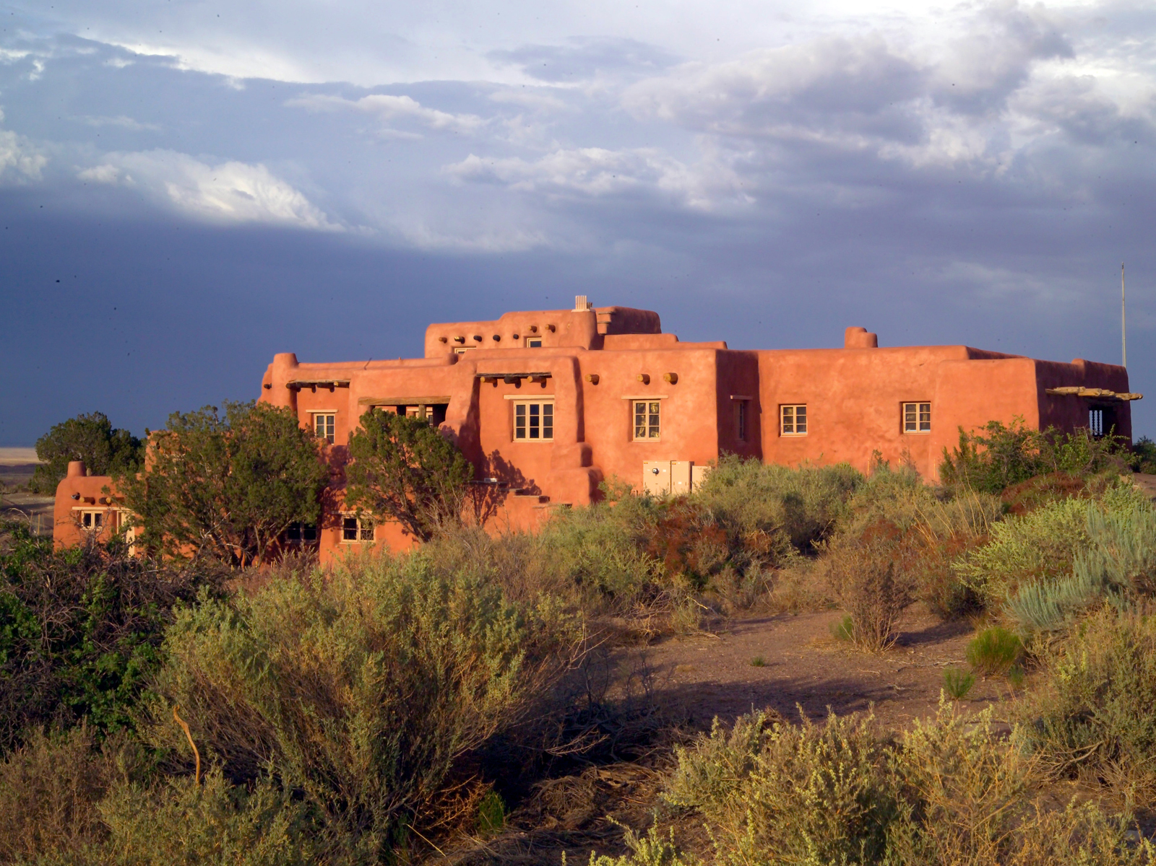

Painted Desert Inn National Historic Landmark. NPS Photo

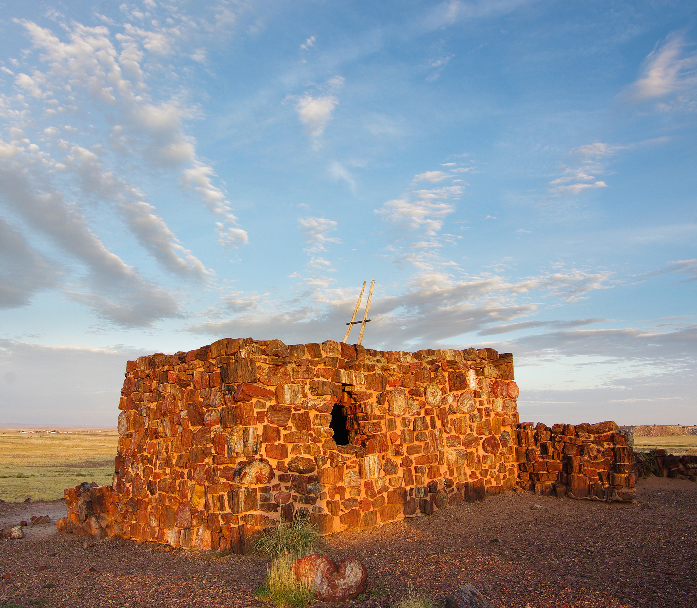

Agate House. NPS Photo

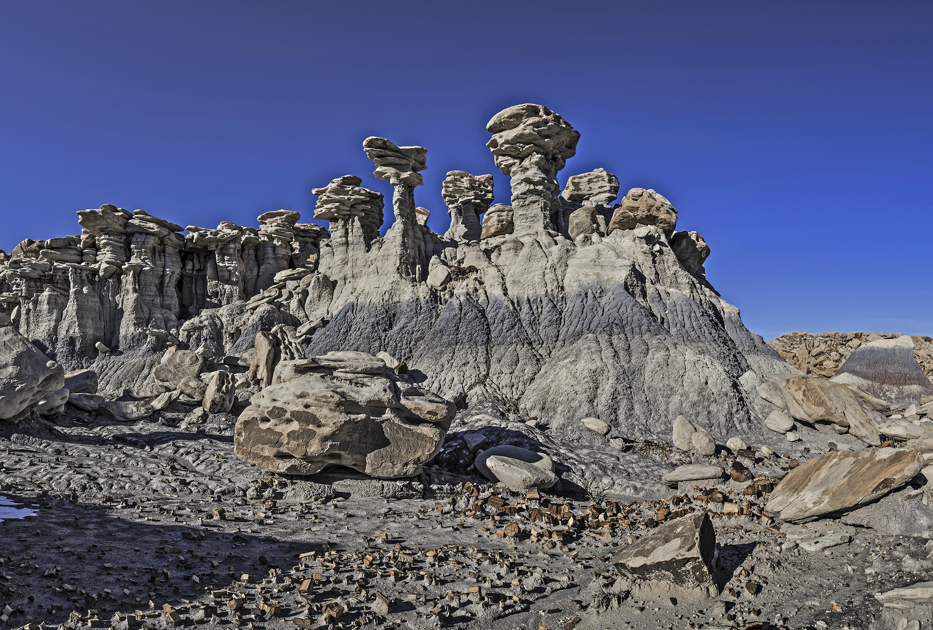

Devil's Playground. NPS Photo

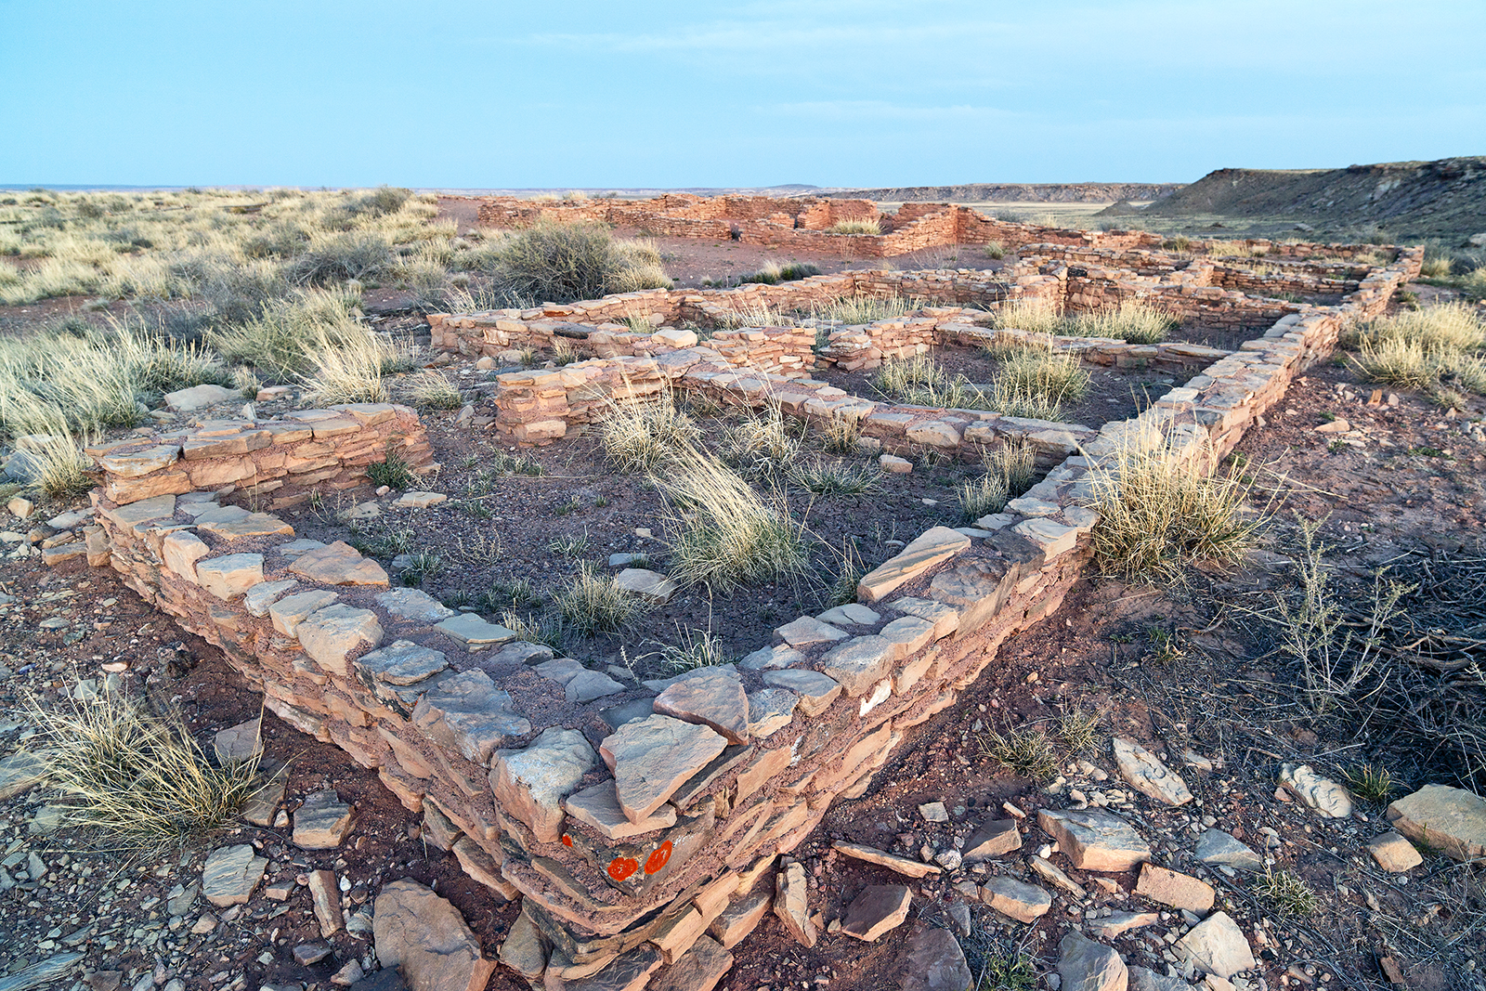

Puerco Pueblo. NPS Photo/Andrew V. Kearns

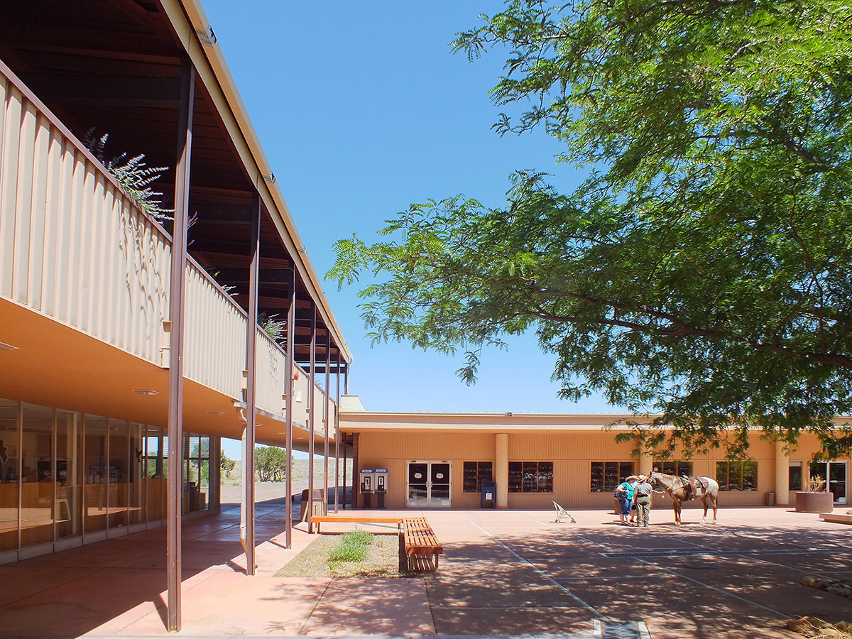

Painted Desert Community Complex Plaza. NPS Photo

## Operating Hours

Park Road hours of operation. Closed Thanksgiving and Christmas.

## Contact Information

### Address

1 Park Road  
AZ  
86028

### Website

https://www.nps.gov/pefo/index.htm